

Space, Range and Merchandising Programme

Infrastructure Stream

Business Systems Design
for
Supported Merchandise Plans and Ranges

Author: I. C. Mortenson

Date: 12/04/2006

Version: 1.6

For sign-off:
Janet Smith | Space, Range & Merchandising Programme Director
Danielle Coe | Range Programme 3 Project Manager
Adam Harrison | IT Space, Range and Merchandising Project Manager
Marcel Borlin | IT Space, Range and Merchandising Programme Manager
Neil Hollins | Head of Space
Jim Clifton | Space, Range and Merchandising Planning & Change Manager
Copied for information:
Steve Player | GT&A
Iain Hamilton | Space Data & Systems Manager
John Wootton | Assort Project Manager

Document Control
Date | Author | Change Description | Version
21/09/2005 | I. C. Mortenson | Initial Draft | 0.1
22/09/2005 | L Toussaint | Amendments to business process requirements | 0.2
27/09/2005 | I. C. Mortenson | Insertion of To-Be process | 0.3
04/10/2005 | I. C. Mortenson | Insertion of System Process | 0.4
07/10/2005 | L Toussaint | Amendments & insertion of Introduction | 0.5
10/10/2005 | I. C. Mortenson | Amendments to the System Process | 0.6
24/10/2005 | L Toussaint | Amendments to Business Process | 0.7
27/10/2005 | I. C. Mortenson | Addition of final sections | 0.8
31/10/05 | L Toussaint | Amendments from team review | 1.0
08/11/2005 | I. C. Mortenson | Amendments from Review & Signoff | 1.1
17/11/2005 | I. C. Mortenson | Further amendments from review | 1.2
23/11/2005 | I. C. Mortenson | Further amendments from review | 1.3
25/11/2005 | I. C. Mortenson | Further amendments from review | 1.4
30/11/2005 | I. C. Mortenson | Amendments for Coverage Store Parameter | 1.5
12/04/2006 | I. C. Mortenson | To correct errors which have emerged | 1.6

Contents

1 INTRODUCTION 5
1.1 Management Summary 5
1.1.1 Objectives of this document 5
1.1.2 Project Objectives 5
1.1.3 Background 6
1.2 “Flight-deck” Infrastructure Overview 7
1.2.1 “Flight-deck” Overview 7
1.2.2 Application Overview 7
1.3 Supported Merchandise Plans Overview 9
1.3.1 Deliverables 9
1.3.2 Benefits 9
1.3.3 Assumptions 9
1.3.4 Out of Scope 10
2 “AS IS” BUSINESS PROCESS 11
2.1 Process Overview 11
2.2 Process Description 11
2.3 Issues with Current Process 12
2.4 Current Architecture 14
3 “TO BE” BUSINESS PROCESS 15
3.1 Previously completed steps 15
3.2 Process Overview 16
3.3 New Processes 16
3.4 Business rules: Changes to the Supported Merchandise Plans and Ranges 19
3.5 Other new processes 20
3.6 Roles & Responsibilities 20
3.7 Implications 21
3.8 System & Architectural Changes 23
4 REQUIREMENTS 24
4.1 Business Process Requirements 24
4.2 System Requirements 26
4.2.1 System Interfaces 26
4.2.2 System Parameters 26
4.2.3 On-line Screens 26
4.2.4 The Supported Merchandise Plans and Ranges application should be easy to update and maintain 27
4.2.5 Reporting 27
4.2.6 History Requirements 27
4.3 Non-Functional Requirements 28
Service Level Agreement (SLA) 28
5 DESIGN ISSUES & RISKS 29
5.1 Issues 29
5.2 Risks 30
6 SYSTEM DESIGN 31
6.1 High Level Processing 31
6.1.1 Select an Event and a MGP 32
6.1.2 Supported Merchandise Plans 34
6.1.3 Supported Ranges 37
6.1.4 Reporting 40
6.1.5 Deleting some or all matrices for an event 41
6.2 Screens 42
6.2.1 Select Event and Merchandising Group 42
6.2.2 Supported Merchandise Plans 46
6.2.3 Supported Range 55
6.2.4 Report Full Set of Supported Merchandise Plans and Ranges 65
6.2.5 Delete some or all Supported Merchandise Plan and Ranges for an Event 67
6.3 Reports 70
6.3.1 Exception Report 1 - Introduction 70
Exception Report 1 - Report Layout 70
6.3.3 Exception Report 1 - Description of the Report 70
6.3.4 Exception Report 1 - Field Descriptions 71
6.3.5 Exception report 2 - Introduction 72
6.3.6 Exception report 2 - Report Layout 72
6.3.7 Description of the Report 72
6.3.8 Field Descriptions 73
6.3.9 Full Set of Supported Merchandise Plans and Ranges - Introduction 73
6.3.10 Full Set of Supported Merchandise Plans and Ranges - Layout 73
6.3.11 Report Description of Report 74
6.3.12 Field Description 74
6.4 Other Processes 75
6.4.1 Input Required from Other Processes 75
6.4.2 Outputs to Other Processes 76
7 SYSTEM REQUIREMENTS 77
8 STANDARDS 78
8.1 Screen & Report Design 78
8.2 Error Handling 78
8.2.1 Error Codes 78
8.2.2 Message Handling 80
8.3 Login & Security 80

APPENDIX A ABBREVIATIONS
APPENDIX B DEFINITION OF TERMS
APPENDIX C SCREENS
APPENDIX D INFRASTRUCTURE PROCESS
APPENDIX E BUSINESS RULES

INTRODUCTION

Management Summary

Objectives of this document

This document describes the Business Process and System design for the Supported Merchandise Plans which is part of Phase 1 of the new Space, Range and Merchandising “Flight-deck” project.

This document has 2 main purposes

- As a working document for the IT and business teams
- To facilitate the business process and system design sign off with the business

Sign off of this document is required to ensure that the solution design and final configuration will support the proposed processes and fulfil the business requirements.

The full Infrastructure Process may be seen in Appendix D, wherein this document represents part 9, Review planned space & determine Supported Merchandise Plans.

Project Objectives

The Supported Merchandise Plans will be one of the core components as part of the Space, Range and Merchandising “Flight-deck” Project. The project was initiated to support the following goals:

- To support the new ranging system, Assort
- To maintain all Infrastructure settings and controls in one location
- To provide the ability to create changes to the Infrastructure that will become effective at a future date
- To move the Infrastructure from legacy IT systems to new technology
- To ensure that changes to the Infrastructure are simple for users to manage

Within the “Flight-deck” infrastructure, and to support these goals, the Supported Merchandise Plans has the following objective.

- To create, maintain and make visible the current and future relationship between range class and space.

Background

The current core Space, Range and Merchandising systems are having difficulty coping with the demands placed upon them by continued expansion of the business. Those difficulties include more flexible and varied ranges required for stores, a higher level of planning sophistication and an increased number of stores and formats.

The business is currently developing a new Ranging System to replace the existing tools and spreadsheets, thus removing the constraints and supporting future growth. To support the new ranging systems and other relevant developments within this area the Space, Range and Merchandising “Flight-deck” will create an infrastructure, which will facilitate and support all current and future Space, Range and Merchandising activities.

A series of projects within the “Flight-deck” are planned to deliver the infrastructure required to support the new Ranging System and other systems

The Supported Merchandise Plans will focus on the need to create a relationship between space and range class based on space, range and merchandising information for any future date. The new Ranging System will constrain ranging to Supported Merchandise Plans and Ranges that are supported. Therefore, there is a need for a tool to define the Supported Merchandise Plans and cluster ranges that will be supported, to maintain them and make them visible to other processes.

“Flight-deck” Infrastructure Overview

“Flight-deck” Overview

The schematic below represents the high-level proposed “Flight-deck” infrastructure and the relationships between to support the core business process.

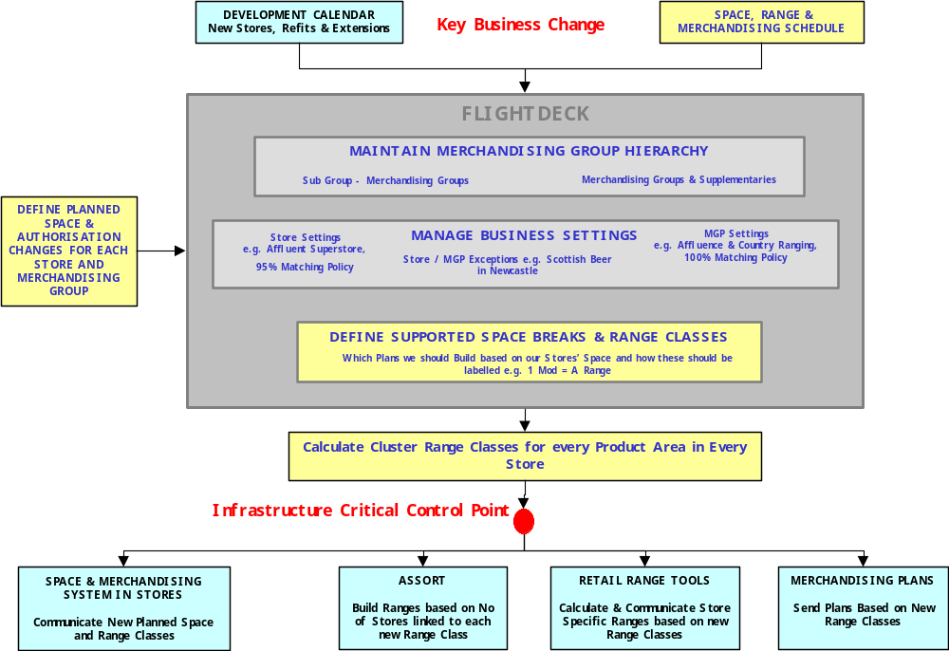

Figure 1 : Infrastructure Overview

The following will describe briefly the function of the main applications within the “Flight-deck” infrastructure. The “Flight-deck” will be configured, on a common platform, to support all Space, Range and Merchandising business processes. At this stage it is assumed that the following applications will be built to complete the infrastructure.

For more details surrounding the core business process in which the “Flight-deck” supports please refer to the Flight-deck Business Process document.

Application Overview

Space, Range and Merchandise Schedule – This application will support the set up and maintenance of scheduled events. It will also be the control point for sending approved data to other systems

Merchandising Group Maintenance – This application will support the maintenance centrally of all merchandising group data.

Pre-Ranging – This application will support the set up and maintenance of characteristics used in ranging merchandising groups. It then associates these characteristics to groups of stores (known as clusters) which are then used in ranging activities

Declaring Planned Space Changes – This application will mainly support the process to upload and make visible all multiple future dated planned space recommendations for any Merchandising group and store combination

Supported Merchandise Plans– This application will facilitate the creation, maintenance and making visible the current and future relationship between range class and space.

Controlling Cluster Range Classes – This application will calculate the range class for each store by merchandising group and provide reporting on the impact of any changes to the Infrastructure

Reporting – Although this is not a specific application, a suite of new reporting will be available to support the business processes through the infrastructure

Controls and Maintenance - This application will support the maintenance of all business parameters (controls), and also security and user access (maintenance) within all areas of the “Flight-deck” infrastructure

Supported Merchandise Plans Overview

Deliverables

This project will deliver:

- A series of screens to create, maintain and delete the Supported Merchandise Plans for a cluster of stores, for a merchandising group during a single event on the Space, Range and Merchandising Schedule
- A series of screens to create, maintain and delete the relationship between range class and space for the same group of stores
- A report to facilitate sign off of the relationship created, with stakeholders
- Summary statistics for the user to understand the impact of the work completed
- A series of exception reports to highlight impacts of the work completed and how these exceptions could be managed
- Facility to make the relationship created available to other systems
- An updated definition of the roles and responsibilities relating to the completion of this task
- An updated business process for completion of the task
- Training materials and associated training for the user
- A screen to make visible to stores the current and relevant future matrices showing the relationship between range class and space, for a merchandising group

Benefits

The key benefits that this project will deliver are:

- Enabler for improved control of the products and ranges available to customers
- Consistent approach in the centre to the products and ranges available to customers, by following a common process
- Consistent visibility of supported Merchandise Plan data at the centre and in store
- Enabler for better decision making in store and in the centre
- Enabler to improve Merchandise Plan coverage by the centre

Assumptions

The following assumptions have been made in order to design the solution to support the business process

- Screen and report layouts included in this document are indicative only
- All formats/countries/product areas following the processes documented are in scope for this development
- All merchandising groups have an equipment type set as standard, and a worthing factor, in the equipment matrix
- Pre-ranging will provide both the merchandising group level store ranging cluster, and any merchandising group level exceptions where they exist
- Information available on store numbers by equipment type and Merchandise Plan, will include only stores that are authorised for the relevant merchandising group
- A-Z range classes are available for use. These will be on an appropriate table (along with a Sequence Number) and may be varied
- Technical and business infrastructure will be in place
- Project can be delivered in isolation from other associated hardware
- IT support will be in place to sustain new technology

Out of Scope

The following is out of scope for this project within the infrastructure:

- Decommissioning of spreadsheets currently used to complete this process (this will be covered by the Controlling Cluster Range Classes project)
- Changes to the ‘range to space’ calculation
- Developments to other systems
- Design architecture for the Flight-deck

Express Stores are in scope for this project within the infrastructure but until such time as they are on a Space Database they will not be fully functional.

“AS IS” BUSINESS PROCESS
The Supported Merchandise Plans are the set of equipment types and Supported Merchandise Plans that will be supported for a merchandising group. For each supported Merchandise Plan on an equipment type, Commercial must create a range and Merchandising must build a Merchandise Plan.
In the As-Is process, the Natural Work Team determines the Equipment Types and Supported Merchandise Plans that will be supported. When the ranges and Supported Merchandise Plans have been built and released into Live then the Space and Merchandising System (GR) uses them to build the Supported Merchandise Plans Matrix in the system. This matrix is then used in Range to Space calculations.

Process Overview
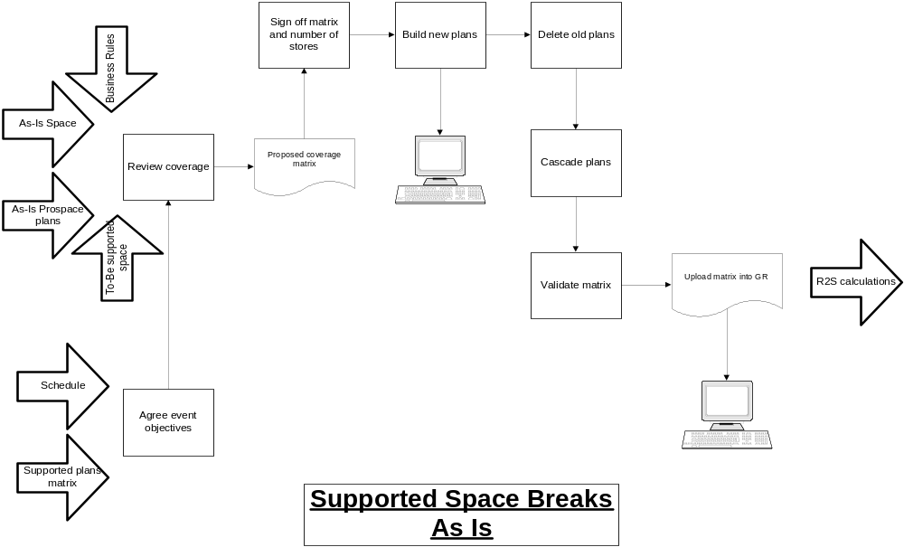
The following diagram shows the existing process

Process Description

- The Natural Work Team (NWT) meets and defines the objectives for the Merchandising Event. The NWT may include representatives from Space, Merchandising, Commercial, Property, Customer Plan, etc. This meeting is held around 26 weeks before the scheduled event.
- The Operations Team review current coverage using the Merchandise Plan Coverage report (Commercial Reporting System) in the light of the Merchandising Objectives. Current Business Rules, As-Is Space in the Stores, As-Is Plans in ProSpace and To-Be Planned Space also inform this review.
- The outcome of this is the list of proposed Supported Merchandise Plans.
- The Merchandising takes the list of proposed Supported Merchandise Plans to the Commercial team to agree and sign off. This list must be agreed around 18 weeks before the scheduled event, so that work on the Supported Merchandise Plans can begin.
- Proposed ranges are physically merchandised at the Merchandising Centre
- The Merchandising team builds new Plans, based upon the list of proposed Supported Merchandise Plans, in ProSpace.
- The Merchandising team deletes the old Merchandising Plans from ProSpace, in the final week before the scheduled event.
- Also in the final week before the event, Merchandising cascades the Plans so that the Plans move to ‘Pending’, then to ‘Live’.
- The new Plans are fed to the Space and Merchandising System (GR), which uses them to build a new Space Matrix (or Supported Merchandise Plans Matrix). A report is produced of changes to the Matrix, based on the plans live in ProSpace on the Saturday night at the start of the event week.
- During the event week, the Range Programme team validates the Space Matrix by checking the list of changes and their impacts, with the Senior Merchandising Managers and the Space Managers.
- The Matrix is loaded by CW Support and becomes the new live Matrix in the Space and Merchandising System, from around Wednesday of the event week.
- Matrix is used for Range to Space calculations.

Issues with Current Process
- Supported Merchandise Plans are only defined in the system at the very end of the New Merchandise Plan process, so are not available for use in other systems until the event live week
- Difficult to understand precisely the impact of changes on Merchandise Plan coverage, particularly when there are changes to the merchandising hierarchy, so the impact of an event on stores cannot easily be forecast
- Limited opportunity to understand the impact of the changes on store range classes, so if errors are introduced there is little time to correct them before stores are affected adversely
- Limited visibility for stores of the future supported plans, to help them understand planned space changes and new range classes, until after the change
- Limited visibility to the ranging system, of the Merchandise Plans and range classes that are supported, so buyers are able to range products to range classes where no Merchandise Plan exists.
- Limited management information available in the system to the day job team, to inform their decisions on which Supported Merchandise Plans and ranges should be built to support stores. All management information must be obtained by querying the data warehouse directly, which requires specialist knowledge.
- The complete set of business rules defining the level of support required through Supported Merchandise Plans and ranges are not documented
- The space matrix used for calculating future dated range classes must be manually created by the space team, and can be overridden if the merchandising team build a different set of Supported Merchandise Plans to those expected. This means the impact on stores could be different to the expected impact.
- No visibility of which stores are currently unsupported, or what range class these stores are receiving, based on the existing space matrix, so it is not simple to understand what could be done for unsupported stores to provide a better Range to Space match.

Current Architecture
The following is a diagram of the existing architecture, showing the interface from the ProSpace system to the matrix in the GR system. The Space Team maintains the Equipment Matrix through a spreadsheet.

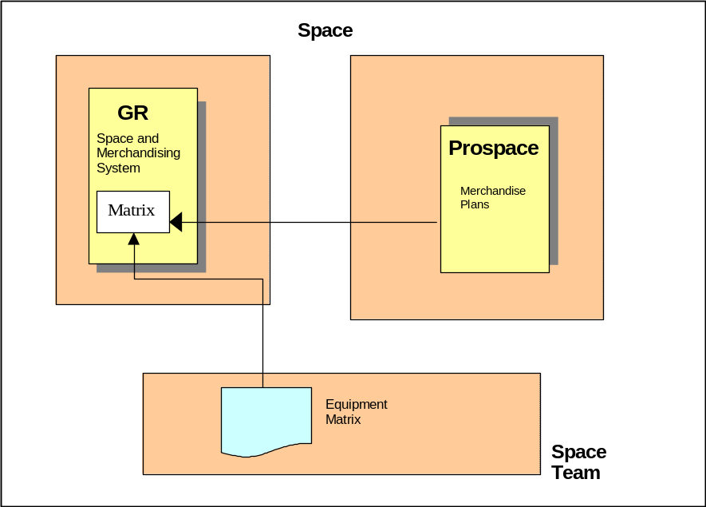

The current and pending plans are sent from the ProSpace System to the Space and Merchandising System (GR) at the weekend.

The weekly processing on the Space and Merchandising System reads these Supported Merchandise Plans, builds a new Supported Merchandise Plans Matrix and produces an impact report.

“TO BE” BUSINESS PROCESS

This is the To-Be business process for creating, maintaining and deleting the Supported Merchandise Plans and Ranges. This task may be completed only when associated with an event on the Space, Range and Merchandising Schedule. For changes to the Supported Merchandise Plans to be valid, all clusters whose Supported Plans are to be changed must be on the schedule; the Schedule is the means of communicating the upcoming changes to the Stores. If changes were to be made to Supported Merchandise Plans and Ranges outside of the Schedule then the stores may change range class without any communication from the centre that ranging and merchandising work should be completed.

Previously completed steps
The following steps must be completed before the first stage of the new process and are therefore out of scope:

- Operations Team will produce the As-Is Coverage report for the MGP(s)
- NWT will review the As-Is Coverage report to define the objectives for the event
- Operations Team will use a standard template to define the infrastructure changes required to support the Event objectives
- Operations Team and Space team will enter all other required changes to the infrastructure (e.g. Merchandising Group hierarchy changes and ranging cluster changes)

Process Overview
The following is a diagram of the new process:
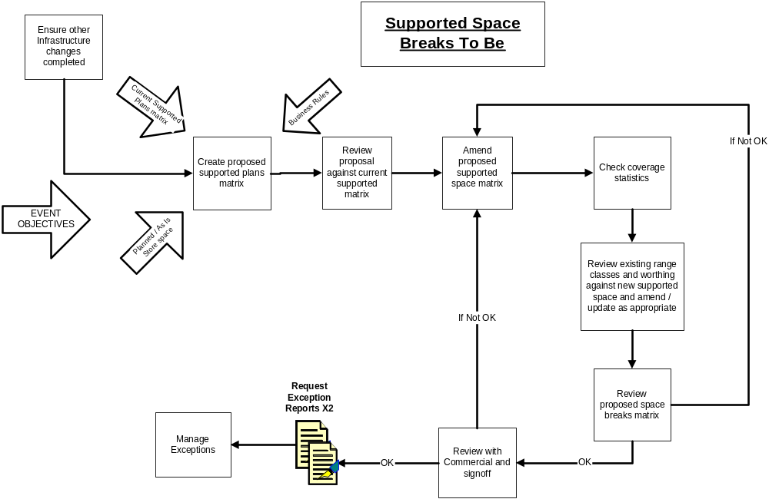

New Processes
Although the RACI is still to be finalised, the following are details of the individual process steps in the new process:

Ensure other infrastructure changes completed
Operations Team will check that all the steps preceding this process are complete, using the list of changes created at the NWT meeting. This includes making any necessary changes to Merchandising Group hierarchy or ranging clusters, or loading any planned space changes for this event.

Create proposed Supported Merchandise Plans and ranges matrix
Space Manager creates the proposed Supported Merchandise Plans and ranges matrix in the system by viewing the number of stores by equipment type and number of mods, overlaid with the latest valid Supported Merchandise Plans matrix.

Review proposal against current Supported Merchandise Plans matrix
Space Manager will review the proposed matrix against the current matrix and the business rules for coverage. These rules are of the form: any Space Break and equipment type code which has more than x stores should be supported to ensure stores receive an appropriate range and Merchandise Plan; this x is a parameter which may vary with Cluster (depending on the Ranging Attribute Values of the Cluster). How this Parameter is found is described in Appendix E. If the process is completed without any changes to the proposed matrix, the default matrix would support all Supported Merchandise Plans recommended by the business rules, and none of the Supported Merchandise Plans that were not recommended.

Amend proposed supported Merchandise Plan matrix
Space Manager will update the Supported Merchandise Plans matrix to show the Supported Merchandise Plans and equipment types that will be supported for this event. This may include supporting Supported Merchandise Plans that are not proposed by the business rules, if required (e.g. to support future UKBE work), or not supporting some Supported Merchandise Plans that were proposed by the business rules (e.g. if an equipment type is being phased out). At any point, the user could return to the original proposal based on the business rules, and remove any extra amendments they have added.

Check Coverage
Space Manager will check the Merchandise Plan coverage that would be achieved with the new Supported Merchandise Plans matrix. If the coverage achieved across the whole merchandising group is not acceptable, the Space Manager will return to step ‘Creating the Supported Merchandise Plans’ as above, to produce a more suitable Supported Merchandise Plans matrix.

Review and update existing Range Classes and worthing
When satisfied with the proposed Supported Merchandise Plans, the Space Manager will review the existing range classes and worthing associated with each supported Merchandise Plan and equipment type. Where necessary the Space Manager will add to, amend or delete existing range classes to ensure that all Supported Merchandise Plans are labelled with a range class. The Space Manager will review the worthing achieved against the existing worthing settings, to check that the relationship between range classes on different equipment types is acceptable.

Review proposed Merchandise Plan matrix
Space team, Operations Team and Merchandising team will review the completed matrix, to ensure it meets the Event objectives. If it is not acceptable, then the Space Manager will return to step ‘Creating the Supported Merchandise Plans’, as above.

Review with Commercial
Space Manager will review the matrix with the Commercial representative for the event, to ensure the number and labelling of the ranges is appropriate. If not appropriate, the Space Manager will return to ‘Review and update existing Range Classes and worthing’, as above. If appropriate, the Commercial Team will later build the agreed ranges.

Manage exceptions
Space Manager will produce two exception reports to be reviewed with the Operations Team. These are:

- Stores with planned space outside the supported range of Supported Merchandise Plans
These stores may not receive a good fit of Merchandise Plan or an optimal product range for their space, given that they are outside the range of Supported Merchandise Plans for their cluster. The number of stores in this category should be minimal, because the Space team will already have planned space changes to any stores where their current space for the relevant merchandising group is outside of expected limits (this business process forms part of the Planned Space Changes project).
To manage these exceptions the Space Manager will consider either increasing the number of Supported Merchandise Plans to support these stores, or changing the stores’ cluster for the relevant merchandising group in Pre-Ranging, if a better fit could be achieved. This will involve returning to step ‘Creating the Supported Merchandise Plans’ in the process, or using the Pre-Ranging application, which is outside the scope of this project.

- Stores previously managed as exceptions, now covered by own cluster
Any store/merchandising group combination which is set up as an ranging exception at the launch date of the event, but which would be covered by it’s default merchandising group cluster on that date, will appear on this report.
The Space Manager will decide whether to remove the merchandising group level exception for each store. If required this step will be carried out using the Pre-Ranging application, which is outside the scope of this project. Of course the Store/MGP may have been made an exception for reasons other than obtaining a better fit to a Plan; in which case the Store/MGP may well remain an exception.

Release Supported Merchandise Plans matrix
Space Manager will confirm the Supported Merchandise Plans matrix for the event, making it available to other Infrastructure systems. The matrix can then be used to run the Range to Space calculation and produce reporting.
Later, Commercial will build the proposed ranges, and the Merchandising team will build the required Supported Merchandise Plans.

Business rules: Changes to the Supported Merchandise Plans and Ranges

 | If all clusters on the Schedule for the Event | If not all clusters on the Schedule for the Event
New merchandise plan | The set of supported merchandise plans can be amended for any cluster  Any range class label can be changed | The set of supported merchandise plans can be amended for any cluster involved in the Event.  Any range class label can be changed but this should be avoided where possible to ensure no mismatch is introduced between the ranging and merchandising systems and the Matrix.
Refresh (20% change) | No new merchandise plans should be supported  No re-labelling of any range class labels | No new merchandise plans should be supported  No re-labelling of any range class labels
Update (10% change) | No new merchandise plans should be supported  No re-labelling of any range class labels | No new merchandise plans should be supported  No re-labelling of any range class labels

Other new processes
Two additional new processes are required to manage the Supported Merchandise Plans matrix, which must be supported by this application. These are:

- Amend a matrix that has already been created for an event
Achieved using the process described above, entering at the appropriate process step depending on the aspect requiring amendment. This process would be used when the Supported Merchandise Plans that are supported require amendment, but the merchandising groups and clusters that exist and have been set up are still valid.
- Delete matrices that have been created for a merchandising group in an event
One or more matrices for a merchandising group (i.e. matrices for one or more clusters) may be deleted at the same time. This process may be used for example when the clusters defined for a merchandising group or for an event are changed, or when the matrices defined for an event need to be entirely reworked.

The full business process for each of these is described in the business process for the Flight-deck.

Roles & Responsibilities
The roles and responsibilities for the Supported Merchandise Plans and Ranges have not yet been agreed with all relevant parties. However, the working assumption is that the following will be in place:

Who | What | Why
Space Team | Maintain Worthing Factors on Equipment Matrix | Define interpretation of space, relationship between different types of equipment
Space Manager | Review Planned Space vs. current Supported Merchandise Plans; if no planned space for event use previously planned or actual | Identify changes to Supported Merchandise Plans
Space Manager | Review Planned Space vs. business rules on coverage | Identify changes to Supported Merchandise Plans
Space Manager | Create and input new matrices for a scheduled event | To enable labelling of Range Classes, improve coverage, maintain full record of Supported Merchandise Plans
Space Manager | Assign a Range Class to Supported Merchandise Plans | Define relationship between Supported Merchandise Plans and Range Classes
Space Manager, Operations & Merchandising Teams | Review matrix and Range Classes against objectives | Confirm objectives met, that plans and ranges required can be built  Identify constraints
Space Manager | Amend /delete Supported Plans and/or Ranges | Delete cluster /scheduled event
NWT | Set event objectives
NWT | Review impact of changes against objectives | Confirm objectives met and that plans and ranges built are those required.  Identify constraints
NWT | Sign off changes to the Supported Plans
Stores | Capture space accurately | Inform centre of space and receive appropriate plans and ranges
Stores | View Supported Plans (relevant to the store) | Understand relationship between Space and Range Class

Implications

- Roles and responsibilities
Today the Programme team are involved in the releasing of the Space Matrix each week; in the future the responsibility for creating, maintaining and deleting the Supported Merchandise Plans and Ranges, and confirming any changes, will lie with the day job Space team.
Responsibility for signing off changes to the matrix will move from the Senior Merchandising Managers and Space Managers to the NWT.

- Timings
Currently the Supported Merchandise Plans matrix is finalised in the event week, following a change. The new Supported Merchandise Plans and Ranges will normally be finalised approximately 18 weeks before an event, and before any ranges or Supported Merchandise Plans are built.
The sign off of changes to the Supported Merchandise Plans matrix will move from weekly sign off of all changes, to sign off of event specific changes at the relevant point in the event critical path.
This means that the matrix will be available for use in the automated range to space calculation from 18 weeks before the scheduled event.

- Impacts on other parts of the Infrastructure
The Range to Space calculation will be able to use the new matrix to link stores’ space to range classes. The use of the new matrix in the Range to Space calculation forms part of the Controlling Cluster Range Classes project, and is out of scope for this application.

- Impacts on other processes
It will no longer be possible to create Supported Merchandise Plans or ranges for Supported Merchandise Plans that are not identified as supported, i.e. not in the Supported Merchandise Plans matrix.
Spreadsheets currently used to complete manual parts of the process, such as the weekly loading of the Supported Merchandise Plans matrix, and calculation of future dated range class, must be decommissioned

System & Architectural Changes

Supported Merchandise Plans will be maintained in and updated on the Infrastructure or Flight-deck System.

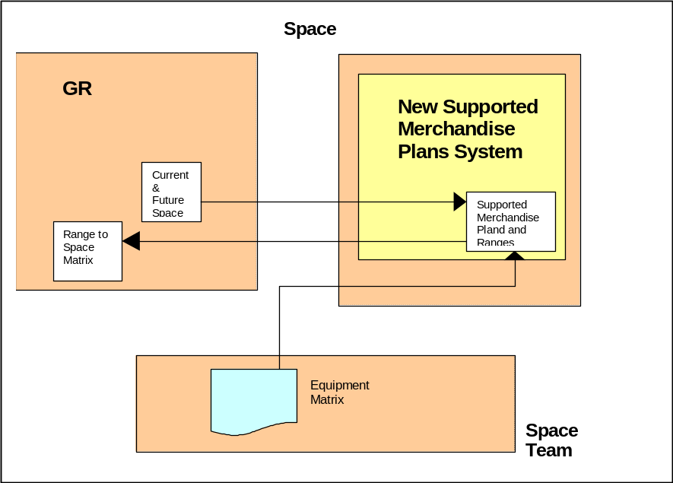

The new data that represents the Supported Merchandise Plans Matrix will be maintained from within a new system, which maintains the ‘flight-deck’. The actual data will reside within the flight-deck system, in new tables.

The Current and Planned Space will be read from the new tables on the Space and Merchandising System (GR) and used during the maintenance of the Supported Merchandise Plans and Ranges.

When the data is confirmed, it will be used to update the Supported Merchandise Plans and Ranges, within the flight-deck system, and will then be available for associating Range Classes with future space.

REQUIREMENTS

To meet the needs of the Range to Space calculation and other Systems that require information on which Supported Merchandise Plans are to be supported, the following are required:

Business Process Requirements

- Over time to view number of stores by Merchandise Plan/ equipment/ cluster /merchandising group
For each merchandising group in an event on the schedule, to view the number of stores with each equipment type and Merchandise Plan, for each cluster in the merchandising group. This is to enable the user to decide which Clusters and Equipment Types should be supported with Supported Merchandise Plans and Ranges, as part of this event.
The information should be available in the form of a matrix for each cluster. This matrix should be available for each cluster regardless of whether the cluster itself is included in the scheduled event.

- To view the Supported Merchandise Plans and Ranges from the last valid space matrices
On viewing the matrix for a particular cluster, the user should also see the Supported Merchandise Plans that were supported in the last valid matrix for that cluster. This is to enable the user to see the amount of change they are creating from the existing state at the time of the event and implies the amount of work that will need to be done for this event, by Merchandising and Commercial.

- To recommend Supported Merchandise Plans against business rules
The matrix should display the current business rules for Merchandise Plan coverage, to help the user decide which Supported Merchandise Plans and equipment types should be supported. Suppose that 5 is the business Parameter for the minimum number of stores to be supported for this Cluster, then if there are 5 stores or more in a particular Merchandise Plan then this Merchandise Plan should be highlighted to the user as one that must be supported. How this Parameter is determined is defined in Appendix E.

- Over time to create /amend /delete elements of, or whole, supported Merchandise Plan matrices
For an event, the user should be able to create a new set of Supported Merchandise Plans within a matrix, to amend elements of a matrix previously created for the event, or delete a matrix for an event.
Where a new matrix is created for an event, or a previously created matrix for the event is amended, this matrix will be used in the Range to Space calculation for that cluster, from the time of the event and going forward. Where a matrix is deleted, the last valid matrix for the cluster will continue to be used from the date of the event and going forward.

- To view the range class associated with Supported Merchandise Plans that are already supported
Following the insertion of the Supported Merchandise Plans for the clusters in a merchandising group, the user must assign a range class to each Merchandise Plan. To enable the user to assign appropriate range class labels, the existing range class labels should be displayed for any Supported Merchandise Plans which are being retained from the last valid matrix.

- Ability to manually associate a Supported Range with a supported Merchandise Plan and to amend existing range classes
The user must be able to assign a range class to each supported Merchandise Plan, taking into account any range class labels that already exist. Existing labels can be overwritten or retained.
The range class labels are to be assigned Cluster by Cluster.
Where an individual cluster is not on the schedule for a given event, the range class labels for that cluster may not be changed.

- To view the standard worthing relationship between equipment types, and the actual relationship created by populating the matrix
When the relationship between space and range class has been created across all clusters, the user must have the ability to review the worthing relationship achieved for each Merchandise Plan and cluster, against the standard worthing relationship set in the equipment matrix. This is to ensure a satisfactory relationship has been achieved for this merchandising group, and that the Merchandising team will be able to build Supported Merchandise Plans for this merchandising group that will achieve level run down.

- Exception reporting to manage stores which are unsupported given the matrices that have been recorded
The user must be able to identify through exception reporting any stores that will not be linked to a suitable Supported Range by the Range to Space calculation, due to the work that has been completed on the matrix. This is to provide the user with the opportunity to change the ranging cluster of that store for this merchandising group, to produce a more suitable link to a Supported Range.
The user must be able to identify through exception reporting, any stores that have a different ranging cluster for this merchandising group compared to their store level cluster, but due to the work completed on the matrix could now revert to the store level cluster for this merchandising group.

- To confirm changes to Supported Merchandise Plans
The completed Supported Merchandise Plans matrix must be confirmed by the user, before being used in other steps in the process. This is to ensure that only completed matrices are used in the later stages of the process.
Where the user starts work on a stage of the matrix creation but the work is not completed, there is no requirement to save that incomplete stage.

- Visibility to stores of relevant matrices that are valid over the next 6 weeks
In order to make sense of planned space changes and their associated range classes, which are visible to stores from 6 weeks before a scheduled event, stores must also have visibility of any relevant matrices that are valid over the next six weeks. Stores should only have visibility of the matrix that relates to their own ranging cluster for that merchandising group.

System Requirements
A separate document, which applies to all applications which are part of the flight-deck, details System and Non-Functional Requirements.

The new data for Supported Merchandise Plans will be held on Flight-deck System and will only be accessed by the new software.

System Interfaces
The Supported Merchandise Plans and Ranges:
- Requires an interface from the Pre-Ranging System containing store clusters for each merchandising Group and event.
- Requires an interface of valid merchandising groups from the Merchandising Group Maintenance System.
- Requires an interface of current and future space, for authorised Store/Merchandising groups, from the Space and Merchandising System (GR).
- Must provide an interface for the Ranges in Progress application database CRDB, Assort and Controlling Cluster Range Classes, including the Supported Merchandise Plans that are to be supported and the associated range class labels
- Must provide an interface to the Data Warehouse to allow ad-hoc reporting from the Supported Merchandise Plans and Ranges.
- Must provide an interface to the Operational Data Store (ODS)

System Parameters
All system parameters must be maintained via on-line screens within the system. These parameters cannot be maintained by every user of the system but only by a super-user.

On-line Screens
There will be screens to create, delete and view supported Merchandise Plan matrices for scheduled events. These screens will show the Supported Merchandise Plans that are supported for an event, and the Supported Range labels associated with those Supported Merchandise Plans. Validation will ensure business rules are adhered to.

There will be summary statistics available to show the User the impact of the matrices created, and the list of clusters for which work must be completed. The user must also be able to view the full set of matrices created for a MGP, for an Event, on the screen.

The screens will allow the user to select values from a list of valid values whenever possible rather than the user typing it the details and the system then validating the information. For example, when the user needs to add a merchandising group a list of valid merchandising groups should be produced on the screen so that the user can select the correct one.

To maintain Supported Merchandise Plans and Ranges that has already been created, the user can either enter the Event ID directly or alternatively use a search facility to select the event based on any combination of Event Name, Merchandising Group, Launch date or Tesco week number.

The Supported Merchandise Plans and Ranges application should be easy to update and maintain
The system should have:
- The same look and feel as the other new applications being developed for the same users
- The capability to create new Supported Merchandise Plans and Ranges for events in any date order.
- The ability to have multiple matrices by cluster, over time, for the same merchandising group code.
- The capability to include all types of merchandising groups e.g. supplementary, where in scope of the project.
- The ability to delete all matrices that have already been created for a merchandising group in an event

Reporting
The system must provide three types of reporting on the Supported Merchandise Plans and Ranges

- Full set of Supported Merchandise Plans and Ranges created for a MGP for an Event
- Exception reporting of relevant store/MGPs for an Event
- Summary statistics showing the impact of the work done, on the number of Supported Merchandise Plans and Ranges required

It must be possible to produce a hard copy of all these reports, based on a particular Event date.

History Requirements
The last valid set of Supported Merchandise Plans and Ranges shall be kept for as long as required. Minimally the Plans must be kept until we have completed the Supported Merchandise Plans and Ranges for the subsequent Event. Other Matrices will only be in the Datewarehouse.

Non-Functional Requirements
These are covered in detail in section 8.

Service Level Agreement (SLA)

These are described in a separate document which details service levels applicable to the whole of the flight-deck application.

DESIGN ISSUES & RISKS

Issues

Issue number | Describe the issue and consequences | Impact
1 | Data Warehouse and Xansa teams are currently running at capacity and may not be able to take on new work in the necessary time-scales | H
2 | Two systems/processes/critical paths will need to be maintained during the transition to the To-Be process | H
3 | Day to day operational issues and other existing projects impact immediate project activities and milestones | M
4 | Currently a small number of equipment types exist that are not defined on the equipment matrix. In the To-Be Infrastructure, it will not be possible to build ranges for these equipment types, or to reconcile merchandise plans and ranges. | M
5 | Some preparatory work will need to be done before moving merchandising groups into the new system, for example to amend the infrastructure of merchandising groups where the relationship between space and range class is different for different clusters | M

Risks

Risk number | Risk & consequences | Likelihood | Impact
1 | There is a limited capacity of expert knowledge currently being shared across multiple projects | H | H
2 | Any change to roles and responsibilities following the signoff of the Business System Design could require re-work to the design, and hence increase costs and extend timelines. | M | H
3 | Transition plan from the As-Is process to the To-Be process is not yet identified, which may produce additional requirements for the project to enable rollout | M | H
4 | To provide the flexibility the business needs in the system some important controls are managed in the To-Be business process, and not the system, e.g. deletion of events, changes to Infrastructure outside of the critical path, which increases the risk of error. | M | H
5 | Aggressive timelines for delivery increase the probability of process or system design error | M | H
6 | All Infrastructure projects are interdependent in terms of system design and business process. Changes or delays to the delivery of any one project will impact on the delivery of all projects. | M | M
7 | Projects using a new technology which is unproven in Tesco. This may result in delay or changes, or additional expenditure. | L | M

SYSTEM DESIGN

High Level Processing

Create and amend
The application to create and amend the Supported Merchandise Plans and Ranges comprises a set of screens which form three logical pieces of work after Selecting the Event and Merchandising Group (MGP). The three sections are: Maintaining the Supported Merchandise Plans for each merchandising group, Assigning Range Classes to the Supported Merchandise Plans for each merchandising group and Printing the results.

In general the User will use the screens in the above order, i.e.

- an Event and a MGP will be selected,
- the Supported Merchandise Plans will be entered for each Cluster which has been associated with the Event and MGP,
- a Range Class will be assigned to each Merchandise Plan in each Cluster,
- the full set of matrices report will be printed for signing-off,
- the User will then start working on exceptions by printing the exception reports

Once the work has been completed in each section the navigation bar, in the left-hand pane of each section, will allow the User to navigate directly to the next section without going back to the Event Selection screen.

Delete
Deletion of matrices is allowable for one or more clusters, or all clusters, in a merchandising group for an event. This action is carried out as one complete piece of work, after Selecting the Event and MGP. The task is carried out is the following order:

- an Event and a MGP will be selected
- the option to delete matrices for the MGP, for the event, will be selected
- the User will be prompted to confirm which matrices they want to delete for the MGP
- the User must confirm, or cancel, the deletion
- if confirmed, the User will be warned to check any matrices created for the MGP that are dated later than this event

Once the work has been completed, or if the task is cancelled, the User will be directed back to the Event Selection screen. No Event or MGP will be pre-selected on this screen.

Select an Event and a MGP

Purpose
The Supported Merchandise Plans may only be created for an Event and a MGP which has been defined on the Space, Range and Merchandising Schedule (the Schedule). This screen is the first screen in the application and allows the User to Select the Event from those on the Schedule and then to select one of the MGPs which has been associated with that Event.

Once the Event and MGP have been selected Supported Merchandise Plans may be maintained, Range Classes may be assigned to Supported Merchandise Plans and the Full Set of Matrices for the merchandising group being worked on may be printed.

Screen Flow

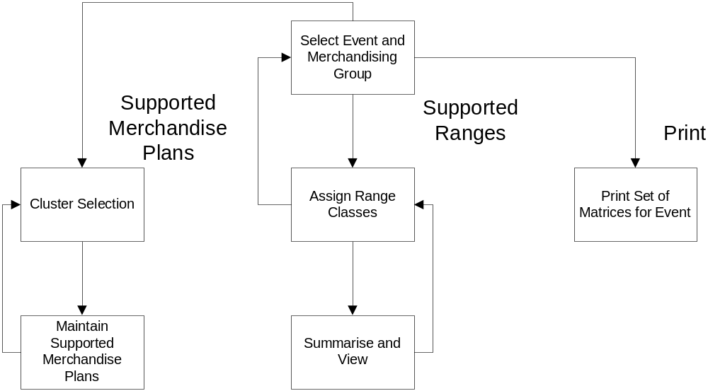

Process Flow
The User may use a drop down list to select an Event Id. If any of the Launch Date, Tesco Week Number, Type of Activity or MGP is already populated then the List of Event Ids is restricted to this context.

Alternatively the User may choose to use a drop down list to select an Event Name. In a manner similar to the above, if any of the Launch Date, Tesco Week Number, Type of Activity or MGP is already populated then the List of Event Names is restricted to this context.

The User may use a drop down list to select a MGP. If any of the Event Id, Launch Date, Tesco Week Number or Type of Activity is already populated then the List of MGPs is restricted to this context.

The User may now choose whether to Maintain Supported Merchandise Plans, Maintain Supported Ranges or Print the Full Set of Matrices for this Event and MGP.

Supported Merchandise Plans
All the Merchandise Plans which are to be Supported (for Supported Equipment Types and Supported Clusters) must be entered in this section.

The User selects a Cluster in the first screen, Cluster Selection, and maintains the Supported Merchandise Plans in the second screen, Maintain Supported Merchandise Plans.

Cluster Selection

Purpose
This screen has more than one purpose. It presents a list of Clusters, which have been declared for the MGP; some or all of these Clusters will have been associated with the Event. If the Cluster has been associated with the Event then this screen allows the User to select the Cluster and to define the new Supported Merchandise Plans for it. If the Cluster has not been associated with the Event then the User may select it to view the Supported Merchandise Plans (which have been defaulted from the previous Event) or to delete all the defaulted plans but may not change them individually.

A Cluster which has no Stores in it and which does not already have Merchandise Plans Supported for it will not be shown.

As well as allowing the User to select the Clusters for maintenance, this screen presents a summary of the work done so far for this MGP. It shows the numbers of supported and unsupported stores, numbers of new plans required, numbers of plans from the last Event no longer required and the total number of plans required. The User has the option of printing this summary as a record.

If no work has been completed for a particular cluster in the merchandising group, no summary details will be shown on this screen for that cluster.

Screen Flow

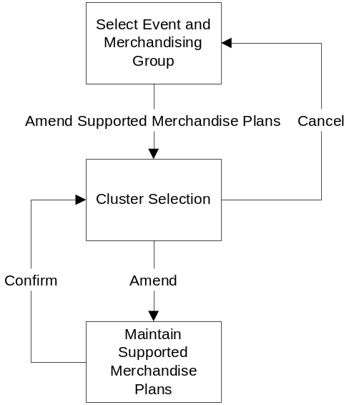

Process Flow
From this screen the User may go forward to Maintain the Supported Merchandise Plans, Print the summary screen or click the Cancel button to go back to Event Selection to select a new Event and Merchandising Group.

Maintain Supported Merchandise Plans

Purpose
In this screen the User may

- view the Equipment Types set up for this MGP (taken from the Equipment Matrix) with the Standard Equipment Type marked and placed at the top of the list
- view the Merchandise Plans supported for these Equipment Types, for the previous Event,
- view the total numbers of stores which will have 1, 2, 3 etc. mods of the Equipment Type at the time of the selected Event,
- declare the Merchandise Plans that will be Supported for the selected Event, for those Clusters which are to be maintained for this Event.

Screen Flow

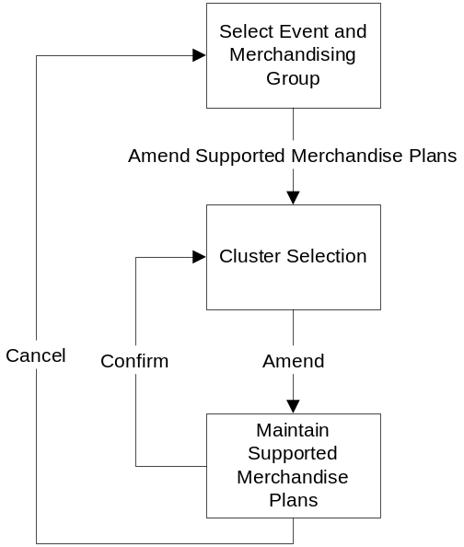

Process Flow
If this is a Cluster which is associated with the MGP but not the Event, it will have had its Supported Merchandise Plans defaulted from the previous Event. These Plans may be viewed in this screen and may all be deleted but not amended individually.

If this is a Cluster which may be amended, and if there are no Supported Merchandise Plans for it, then the Supported Merchandise Plans which should be Supported, according to the Business Rules, will be selected automatically as candidates and displayed (in Green); this will be the case on the first occasion that this screen is entered for the Event and MGP. The User may accept these suggested Plans, delete some or all of them or decide to Support different Merchandise Plans altogether. Then the User may save the Supported Merchandise Plans as they are by clicking the Confirm button or reject all these changes by clicking the Cancel button; confirmation of the decision must be made in either case. The navigation will take the User back to the Cluster Selection screen after processing.

The User has the option, at any time, to revert to the initial position by clicking the Clear All button.

Supported Ranges
After all the work has been done on Supported Merchandise Plans, for all the Equipment Types, for all the Clusters associated with the Event, the User Assigns a Range Class to every Supported Merchandise Plan.

The first screen is used to perform the Assignments and the second screen is a summary that additionally shows the achieved Worthing Factor and permits Confirmation of all the work done.

Assign Range Classes

Purpose
This screen is used to Assign a Range Class to every Supported Merchandise Plan, for every Equipment Type defined; this is done Cluster by Cluster so that Range Class F in Cluster ABC may not mean the same as Range Class F in Cluster PQR.

Range Classes should not be assigned to Supported Merchandise Plans until all the Supported Merchandise Plans have been defined. Whilst it isn’t possible to ascertain that all the Supported Merchandise Plans have indeed been defined, the program will check that at least one Supported Merchandise Plan has been defined for every Cluster which has been declared for the MGP (and which has at least one Store in it).

All the Supported Merchandise Plans, presented as Values of Mods, for all the Equipment Types, for each Cluster in the Matrix for this Event, are grouped together and presented Cluster by Cluster: unique Cluster/ Equipment Type/ Supported Merchandise Plans are presented for the User to assign Range Classes to them.

After assigning Range Classes to all the Supported Merchandise Plans, for all the Equipment Types, for all the Clusters, the User will navigate to the next screen where the input is checked to ensure that every Supported Merchandise Plan has had a Range Class assigned to it and that the Range Class Labels increase in line with the Values of Mods (without duplication). The results of all the work done is summarised for validation and may be confirmed or rejected.

Screen Flow

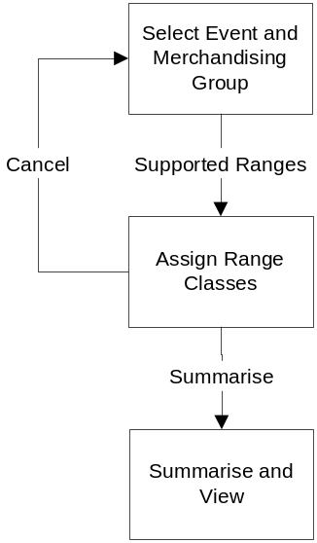

Process Flow
The screen shows all the Supported Merchandise Plans, for each Equipment Type, Cluster by Cluster. The Range Class assigned to each Supported Merchandise Plan, whether defaulted from previous Event or previously entered, is shown alongside each Supported Merchandise Plan and may be amended.

When all the Supported Merchandise Plans have been assigned the User may click the “Summarise” button which brings up the next screen, Summarise and View.

Alternatively clicking the Cancel button will reject all the recent changes and revert the Supported Merchandise Plans and Ranges to the last saved state; this option must be confirmed. Process then continues from the previous screen, Event Selection.

Summarise and View

Purpose
This screen performs certain validation and presents all the assignments of Range Class to Supported Merchandise Plans for all Equipment Types, Cluster by Cluster. These are presented in a compact format that allows the User to see Worthing Factors achieved for each Plan. It also shows whether Range Class Labels apply to different Values of Mods or not.

If there are Plans without Range Class labels or different Merchandise Plans (for the same Cluster and Equipment Type) with the same label then the User will not be able to confirm the matrices and proceed; instead they will be directed back to Assigning Range Classes to correct this.

If the results are valid and what the User would have expected then the assignments can be confirmed by clicking the Confirm button; the assignments will be saved.

Alternatively, if the results are valid but are not correct, the User may click the Cancel button and go back to correct the assignments.

Screen Flow

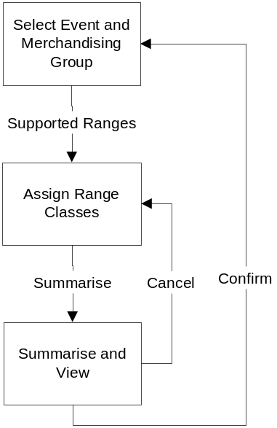

Process Flow
This screen is a read only screen.

If the results are what the User expected then the assignments may be confirmed by clicking the Confirm button. The completed data is saved and the process then continues to Event Selection. The relevant Event and merchandising group are still selected, on this screen.

If the results are not satisfactory the User may click the Cancel button which returns to the previous screen, Assign Range Classes.

Reporting

Print Full Set of Matrices

Purpose
This screen allows the User to print a report that is a full set of all Matrices for the MGP for the Event.

This report enables the User to determine whether or not the work has been done satisfactorily and provides a document that may be signed off to confirm this.

Screen Flow

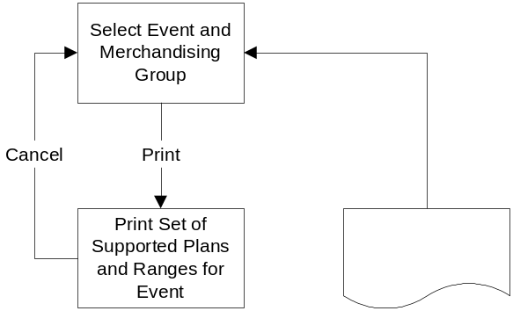

Process Flow
All Matrices for this MGP and Event are shown on the screen, with a scroll bar if required to move around the screen.

The User may click the Print All button and the full set of Matrices will be printed on a report. Alternatively the User may click the Cancel button and return to the Event Selection screen.

Deleting some or all matrices for an event

To delete matrices for a MGP for an event, the event and MGP must be selected from the Event Selection screen. The option to Delete is then selected from the left hand navigation pane.

The next screen lists the clusters for which matrices could be deleted, for the Event and MGP. The User must select the clusters for which the matrices are to be deleted and Confirm. After confirmation, the User will be prompted again before all selected matrices are deleted.

Delete all Matrices for an Event and MGP

Purpose
This screen displays to the User a list of clusters for which matrices could be deleted for this Event and MGP. The User may:

- Select the required clusters and confirm that the list of matrices for the MGP, for the Event, should be deleted
- Cancel and return to Event Selection

Screen Flow

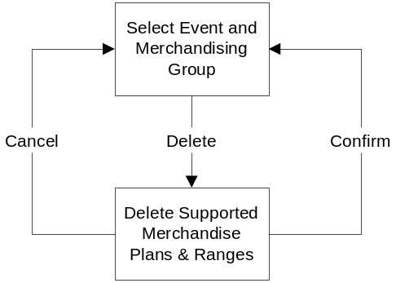

Process Flow

When this screen is selected, the Event, MGP and all clusters will be listed on the screen. The User may select one of more clusters, for which the Supported Merchandise Plans and Ranges should be deleted. The User must then Confirm the selection. On confirmation, the User will be prompted again by a warning message, then on confirming again, the matrices will be deleted and the User directed to the Event Selection screen. Alternatively the User may Cancel the action, returning to the Event Selection screen where no Event or MGP will be selected.

Screens

Select Event and Merchandising Group
This, the first screen of the application, allows the User to select the Event for which work is to be done. The User must also select one of the Merchandising Groups (that are associated with the selected Event) prior to working on the Supported Merchandise Plans Matrices, whether creating, amending or deleting Matrices.

Copies of all the screens, in colour, are in Appendix C.

Navigation

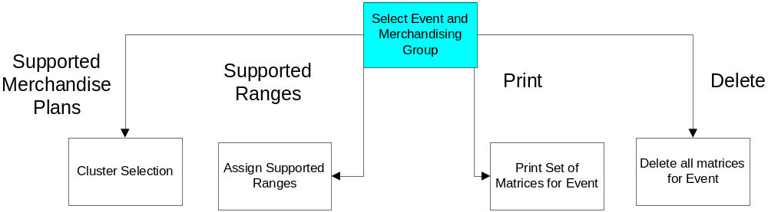

Screen

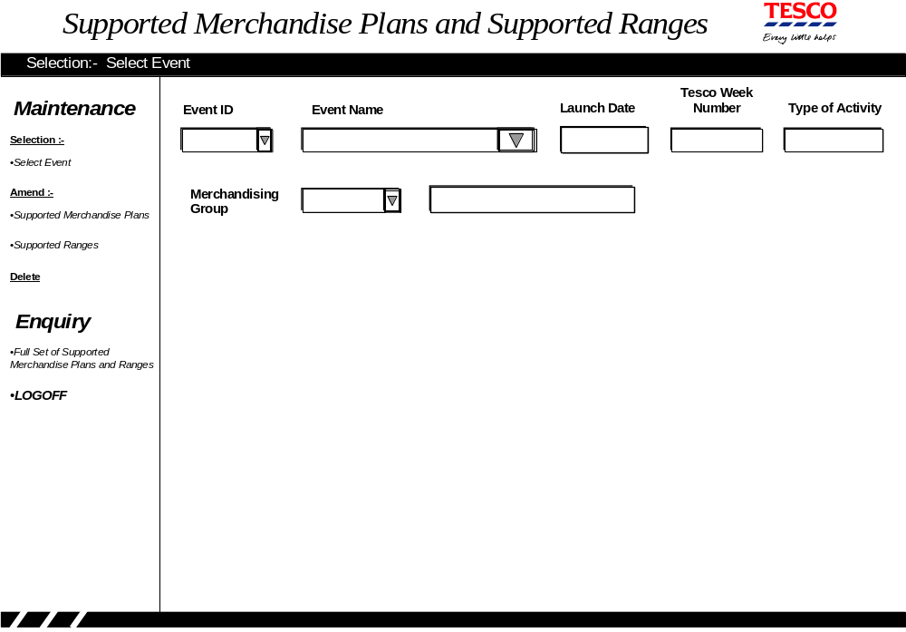

Screen Function

After the Event is selected, the Launch Date, Tesco Week Number and Type of Activity are populated. These may be cleared if necessary, if the User wishes to select a different Event for example.

The Merchandising Group is also selected and its Name displayed. The Equipment Matrix is scanned for this MGP and all the valid Equipment Types are saved. The single character Equipment Indicator is saved, as Equipment Types will be displayed in this sequence. The description for each Equipment Type is saved. The Worthing Factor for each Equipment Type is saved. If there are no Equipment Types for this MGP then an appropriate error message is displayed; after acknowledgement, the MGP is cleared and the User may exit to correct the Equipment Matrix or continue with a different MGP.

The single Equipment Type that is the Standard Equipment Type for this MGP is saved, as this will be displayed first, at the top of all following screens. If there is not ‘one and only one’ such Equipment Type, for the MGP, then an error message (indicating that this must be corrected for this MGP before progressing with this application) is displayed; after acknowledgement, the MGP is cleared and the User may exit to correct the Equipment Matrix or continue with a different MGP.

Navigation from this screen is controlled by selecting options in the left-hand pane. After selecting both Event and MGP, the options on the left-hand pane allow the User to choose between Supported Merchandise Plans, Supported Ranges and Print the full set of Matrices. The User may Exit from this screen, using the left-hand pane, back to the main menu.

Field Descriptions

Field | Description | Comments
Event | The identifier of the required Event is selected from the drop-down list. The list must show Event Name and Launch Date | Must have a Launch Date in the future  If any of Launch Date, Tesco Week, Type of Activity or MGP are populated the drop-down list shows Events in that context only
Event Name | Taken from the Merchandising Schedule | If MGP is populated the drop-down menu shows Events for that MGP, only
Launch Date | Taken from the Merchandising Schedule | This is the Launch Date for the Event as a whole; individual Clusters may have Launch Dates after this date (but within approximately 2 weeks).
Tesco Week | Taken from the Merchandising Schedule | Using the Tesco Week starting on Sunday
Type of Activity | Taken from the Merchandising Schedule | UKBE, New, Update, Refresh and Space Audit
Merchandising Group | Selected from MGPs associated with the Event on the Merchandising Schedule | If Event is populated the drop-down menu shows MGPs for that Event, only
MGP Description | Taken from the Merchandising Group Maintenance System

Supported Merchandise Plans
The Merchandise Plans, which are to be Supported for the Event and MGP, are declared in this section of the application.

Every Cluster that is associated with the Event, for the MGP, which has at least one Store, must have at least one Merchandise Plan defined for it and confirmed. Every Cluster that is associated with the MGP, but not associated with this Event will default to the Supported Merchandise Plans of the previous Event; these do not need to be confirmed and in fact may not be.

There are business rules governing whether or not a Merchandise Plan should be Supported or not, depending on the number of Stores which have that space. These rules are used to pre-populate the Supported Merchandise Plans with defaults, first time through.

Supported Merchandise Plans are maintained using two screens. The first screen, Cluster Selection, is used to select the Cluster to be maintained and the second screen, Maintain Supported Merchandise Plans, is used to define the Supported Merchandise Plans to be Supported.

Cluster Selection – Introduction

The first screen, Cluster Selection, has a number of functions:

- it is a menu of Clusters which are to have Supported Merchandise Plans defined for the selected Event,
- it displays summary information about the work done so far on Supported Merchandise Plans for each Cluster,
- it allows the printing of this summary,
- it acts as a control stage since you cannot get to the next section, Supported Range Assignment, without doing some work for every Cluster (which has Stores in it).

Every Cluster associated with the Event, for the MGP, which has at least one Store is presented for selection; if a Cluster has no Stores in it but already has a Merchandise Plan Supported for it then it must be displayed too. The Clusters are displayed in two groups, each in alphabetical order:

- Clusters that are associated with the Event, for the MGP, followed by
- Clusters that are associated with the MGP, but not associated with this Event

Cluster Selection – Navigation

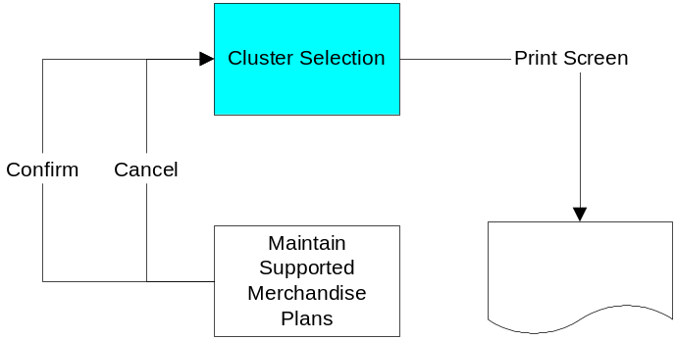

The first screen may be navigated to from Event Selection; it may also be navigated to from any other section of the application, provided the work in that section has been confirmed or cancelled, and an Event and a MGP have been selected.

The User selects the Cluster required and clicks the Amend/ View button to move to the second screen. The User may print the screen, and the summary details, by clicking the Print button, or return to the Event Selection screen by clicking Cancel button.

Screen Layout

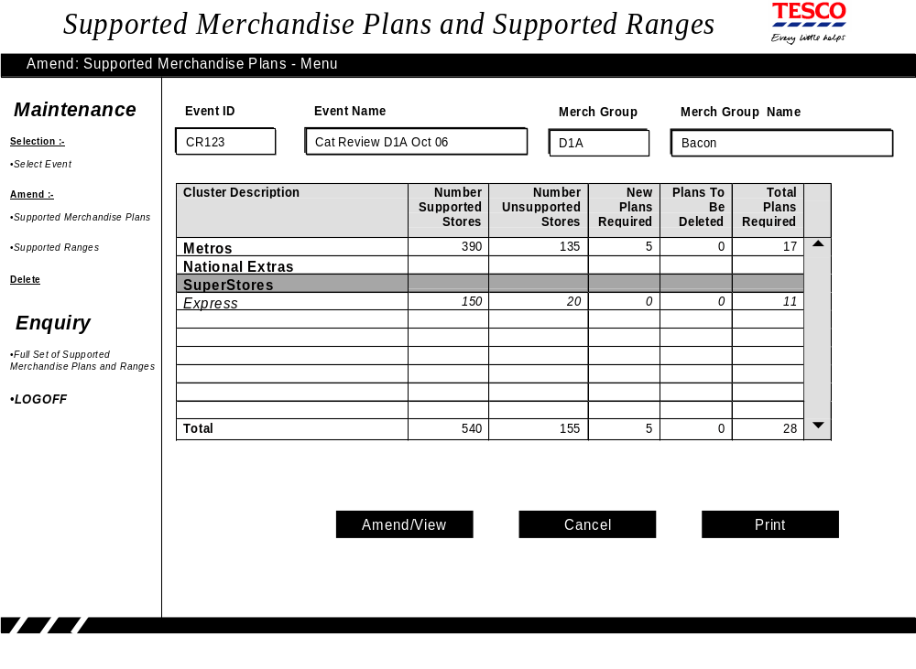

Description of Screen Function
The screen allows the User to select the Cluster whose Supported Merchandise Plans are to be maintained.

The selected Event Id and MGP are displayed at the top of the screen, along with the Event Name and Merchandising Group Name.

Clusters
The Clusters (associated with the MGP) are displayed down the screen, ordered firstly according to whether they may be amended for this event, and then in alphabetical order. The Clusters associated with the Event (which may be maintained) are shown in bold. Those Clusters not associated with the Event (whose Supported Merchandise Plans will defaulted from the previous Event) are shown in Italic.

Stores’ Space
If this is the first time this screen is shown for this Event, in this session, then the Stores in each Cluster will be determined, from Pre-Ranging, and the Space for each of these Stores ‘Space’ is determined, thus:

- If there is a Planned Space entry for this Store/ MGP on the date of the Event/Cluster, held in the Space and Merchandising System (GR), then this Space is used.
- Otherwise, the latest-dated Planned Space entry for this Store and this MGP (which is after yesterday but before the Event/ Cluster date) held in the Space and Merchandising System, is accessed and this Space is used.
- Otherwise the current actual Space, from the Space and Merchandising System, is used

Stores’ Equipment
Again if this is the first time this screen is shown for this Event, in this session, then the equipment type associated with that space is determined as follows for a for a store/MGP:

- If there is a Planned Space entry for this Store/ MGP on the date of the Event/Cluster, held in the Space and Merchandising System, and an equipment type was loaded with the Planned Space change, then this equipment type is used
- Otherwise, Equipment Type is taken from the equipment type for this Store/ MGP as held in the Space and Merchandising System. If there is more than one type then this is held as ‘MIX’ for Mixed; if an unknown type then this will be held as ‘???’.
- If no equipment type can be determined by this method, then the standard equipment type for the MGP, as held in the equipment matrix, will be used.

For each Store the ‘Space’ is rounded to the nearest whole Mod of Equipment. The rounding follows business rules held in the Equipment Matrix at MGP level. This data is saved for later use.

A Cluster without any Stores in it will not be shown unless there is already a Supported Merchandise Plan for it.

Defaulted Plans
Those Clusters associated with the MGP but not with the Event, which have at least one Store, will have Supported Merchandise Plans defaulted from the previous Event. If this is the first time this screen is shown for this Event, in this session, then any of these which do not exist will be created now, for the selected Event. Note: if the following screen has been accessed for one of these Clusters, during this session, and the defaulted Plans have been deleted (with the ‘Clear All’ button) then these plans must not be re-created here.

Work Summary
The screen will display a summary of the work done so far for each Cluster; this will include the Clusters whose Supported Merchandise Plans may not be amended for this Event. This summary may be printed, by clicking the Print button. If no work has been confirmed for a cluster, then no summary data is displayed and the fields are blanks.

Cluster Navigation
The User navigates to the Cluster required using the scroll-bars and/or clicking until the required cluster is highlighted. The User then clicks the Amend/ View button to move to the second screen.

It will be possible to navigate to those Clusters that may not be amended (as well as those that may be). The Supported Merchandise Plans will have been defaulted from those of the previous Event and, whilst they may not be amended individually, they may be viewed or all of them may be deleted.

Clicking the Cancel button will take the User back to the Event Selection screen.

Field Descriptions
There are no fields to be entered in this screen. The screen displays the Clusters (in alphabetical order A – Z, 0 – 9) and a summary of work done for each one so far. Where no work has been done on the Supported Merchandise Plans and Ranges so far, the summary statistics will be blanks.

Amend Supported Merchandise Plans - Introduction
The second screen, Maintain Supported Merchandise Plans, allows the user to:

- view the proposed matrix against the existing matrix,
- view the proposed matrix against Store Space,
- view the proposed matrix against business rules,
- update the proposed matrix for Clusters linked to the selected Event
- clear all the work done so far on this matrix (whether by default or manual entry) in order to start work on the Matrix from the beginning or as part of deleting all the work for an Event.

Amend Supported Merchandise Plans - Navigation

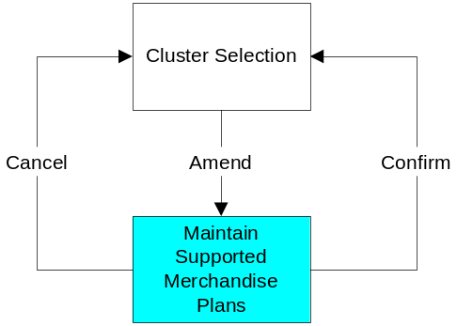

This screen is only navigated to from the first screen of Supported Merchandise Plans, using the Amend/ View button on that screen.

If this is one of the Clusters that may not be amended (one associated with the MGP but not the Event) then the Supported Merchandise Plans will have been defaulted from those of the previous Event. The Plans may not be amended individually but they may be viewed or they may all be deleted (by pressing the ‘Clear All’ button). If the Plans have all just been deleted and the User then presses the Cancel button, Cancelling this deletion, then the User is asked to re-confirm that this is what is required Clicking Cancel or Confirm button returns to the Cluster Selection screen.

For the other Clusters the User may enter changes and Confirm them. By clicking the Confirm button all the changes will be saved.

The User may reject all changes just made, returning the Matrix to the last saved state and returning to the first screen, by clicking the Cancel button; the User will be asked to confirm this option.

Finally the User may click the Clear All button; the User will be asked to confirm this option. On confirmation the application will reject all the work done on the Matrix for this Cluster; the screen will show that no Merchandise Plans are Supported and every cell will be either Red or White.

At this point the User may click the Confirm or the Cancel button, as above. Clicking the Clear All button a second time will do the same as it did first time.

Screen Layout
The following shows the second screen as it will appear the first time the User enters it, when no Supported Merchandise Plans have been manually entered and the system has pre-populated the ones required according to the business rules:

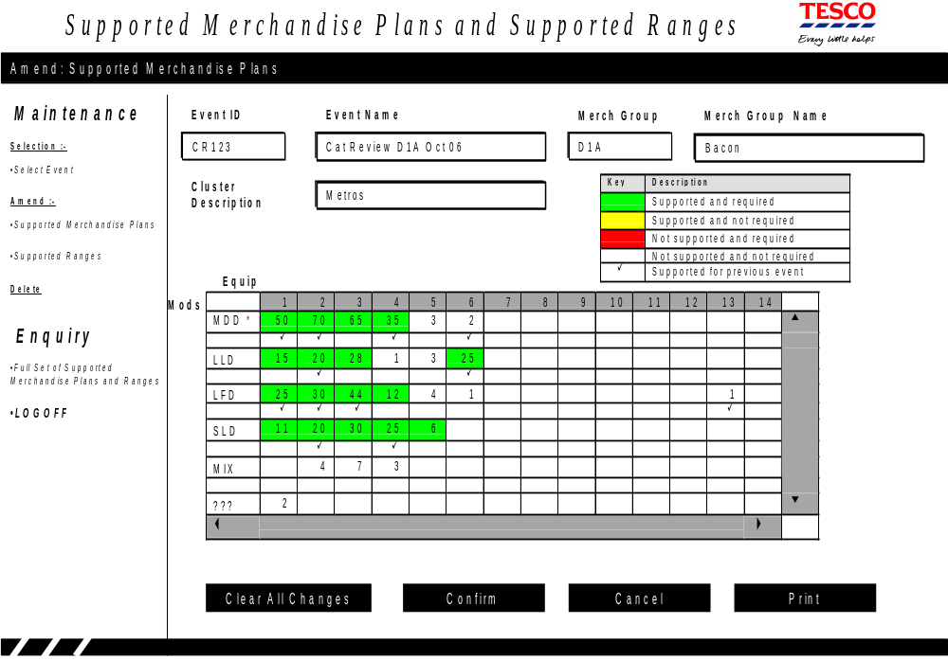

Description of Screen Function
The Event Id, Event Name, MGP and Merchandising group Name are shown along the top of the screen.

The selected Cluster and its name are shown alongside a key, which indicates the RAGing and symbols used on the screen:

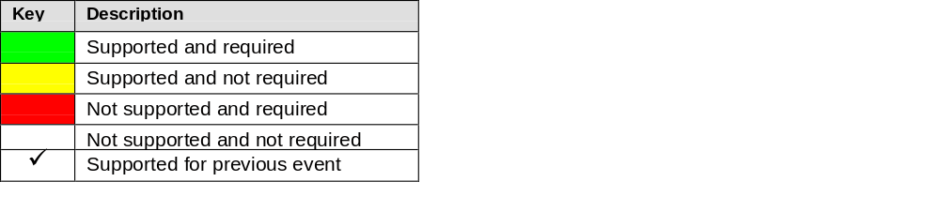
The Equipment Types are shown down the screen with the Standard Equipment Type shown first and marked with a red *; the other Equipment Types are shown in sequence of their single character Equipment Code. If there are Equipment Types below the last one shown on the screen then a red ↓ is shown at the bottom-right of the grid.

Across the top line of the grid are the headings 1, 2, 3 mods etc. for all potential Supported Merchandise Plans.

Across the screen, within the grid, are cells representing the Supported Merchandise Plans (number of mods) of each Equipment Type. If there are any Stores in the estate with this authorised MGP, with this Number of Mods of this Equipment Type then the cell is populated with the number of such Stores. This enables the User to view Supported Merchandise Plans proposed against Store Space.

If there are populated cells to the right of the last one shown on the screen then a red → is shown at the top-right of the grid. The user may scroll across the screen to view or select Supported Merchandise Plans, even if cells are not populated.

In order to view the proposed matrix against the existing matrix, the presence of ✓ just below a cell indicates that this Merchandise Plan was Supported for that Equipment Type in the previous Event.

In order to view the proposed matrix against business rules, the cells are ragged according to the key above. In all the examples the business rule is assumed to be ‘if 5 or more Stores have a particular Number of Mods of a particular Equipment Type then they should be Supported’ (How this Parameter is found is described in Appendix E).

If this is one of the Clusters that may not be amended (one associated with the MGP but not the Event) then the Supported Merchandise Plans will have been defaulted from those of the previous Event, and these may not be amended individually but they may be viewed or they may all be deleted. IF, after deleting all the Plans, the User presses the Cancel button (to cancel the deletion) then this must be re-confirmed before proceeding. Clicking Cancel or Confirm button returns to the Cluster Selection screen. Clicking the Print button enables the screen to be printed.

The User may update the proposed matrix (for this Cluster) by clicking on the cell, which toggles the ‘to be supported/ not to be supported’ state. The cell is consequently ragged according to the business rules, as in the following:

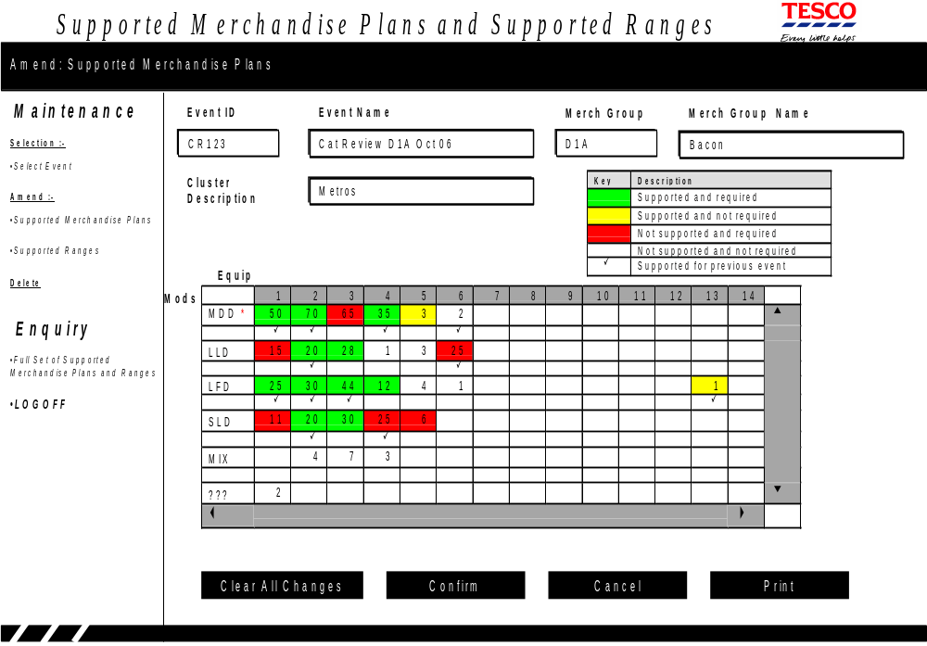

The User may not click on cells for Unknown Equipment Types ‘???’ nor for Mixed Equipment Types ‘MIX’. This is because unknown and mixed equipment cannot be supported.

The user must support at least one Merchandise Plan for every cluster (that has got Stores in it).

The Confirm button will write the Supported Merchandise Plans away to the Matrix and this is how the screen would appear should the User now log-off and come back to it. After confirmation the User will be passed back to the previous screen, Cluster Selection.

The Cancel button will reject all changes made during the current session, return the Matrix to its last saved state, and navigate to the previous screen, Cluster Selection. The User must confirm this choice.

Clicking the Print button will print the screen; it is important that all populated cells (all Numbers of Mods across and Equipment Types down) are printed not just those shown in the current window of the current screen

If the User wants to clear all the work done so far on this matrix, to start again or if all the work has to be cancelled in order to delete the Event, say, then the User may click the Clear All button. (Note that in cancelling all work for the Event the ‘defaulted Clusters must be cleared too.) The screen will show no Supported Merchandise Plans:

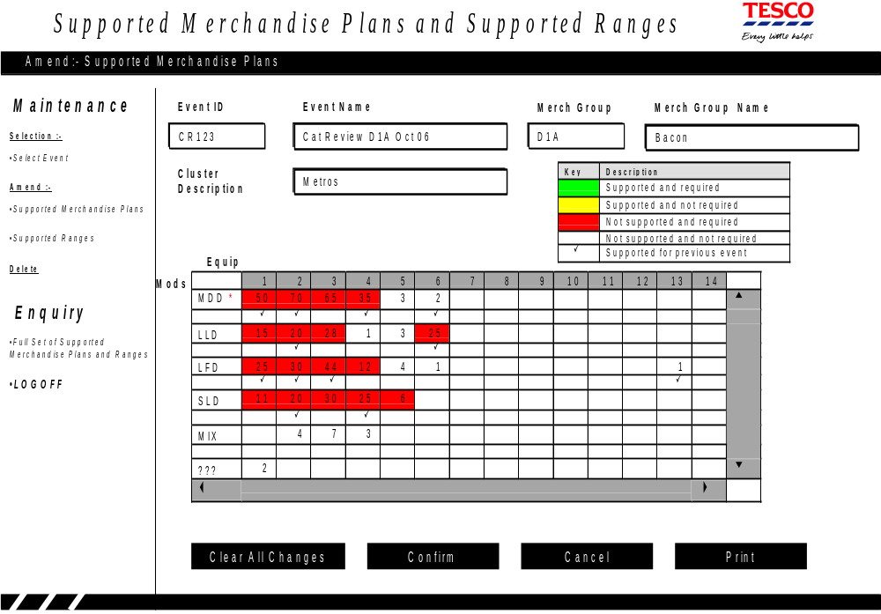

If the User now chooses to Confirm this then all previous work is lost, i.e.:

- There will be no Supported Merchandise Plans, for this Cluster, for this Event,
- any data written to the database, for this Cluster, for this Event will be removed,
- the Matrix, for this Cluster, will return to its original state,
- the Cluster Selection screen will show no statistics, for this cluster.

If the User clicks the Cancel button then the Matrix will revert to its previously saved state.

Process will continue from Cluster Selection.

Field Descriptions
No fields are entered in this screen. Actions are effected by clicking either cells or buttons.

The fields shown are all described in the function description above.

Supported Range
This section enables the User to Assign Range Classes to the defined Supported Merchandise Plans. The same Range Class will not necessarily be assigned to the same Value of Mods across all Clusters.

There are two screens in this section. The first shows all the Supported Merchandise Plans which have been defined (Value of Mods), for all Equipment Types, Cluster by Cluster. It allows the User to assign Range Classes to the Supported Merchandise Plans. The second screen ‘Summarises’ all the Supported Merchandise Plans, all the Equipment Types and all the Clusters into Supported Ranges. It shows the Space (as number of mods), the achieved Worthing Factor and allows anomalies to be easily seen and corrected.

Range Classes should not be Assigned until all the Supported Merchandise Plans have been defined. So the first screen may not be run until at least one Merchandise Plan has been defined for every Cluster associated with the MGP (which has at least one Store in it). The second screen may not be run until every Supported Merchandise Plan, for every Equipment Type, for every Cluster has had a Range Class assigned to it.

Assigning Range Class – Introduction
All the Supported Merchandise Plans which have been defined for all the Equipment Types are grouped, Cluster by Cluster, and displayed.

If the Merchandise Plan for the Equipment Type, for that Cluster, was supported for the previous Event then the Range Class is taken from that set of Supported Merchandise Plans and Ranges. Otherwise the Range Class, shown as blank, must be entered. Defaulted Range Classes may be amended.

Assigning Range Class – Navigation

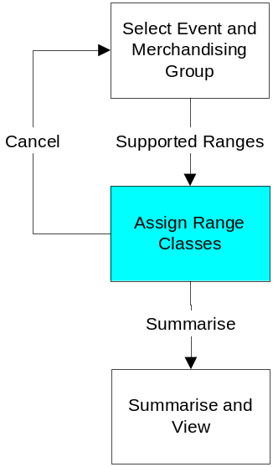

This screen is usually navigated to from Event Selection, using the left-hand pane options; navigation leads to the first screen, Assign Range Class, from which Summarise and View may be reached.

The first screen also may be navigated to from any other section of the application, after the work in that section has been confirmed or cancelled. This of course is providing the pre-conditions are met.

After working on this screen the User may click Summarise button and go to the next screen which summarises the work done (and allows Confirmation) or return to the Event Selection screen by clicking Cancel button.

Screen Layout
The following shows the first screen, used for Assigning Range Classes, as it might appear when entered for the first time:

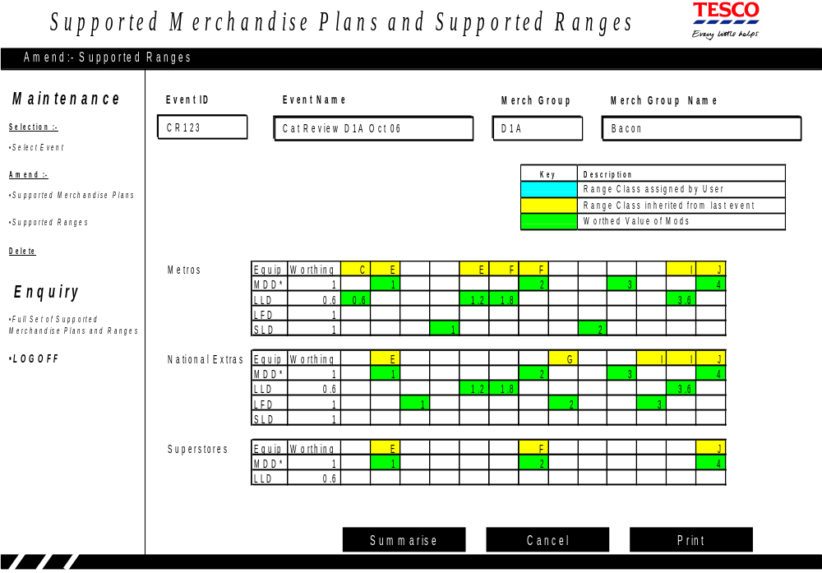

Description of Screen Function
All the Supported Merchandise Plans (for all the Equipment Types, for all the Clusters associated with this MGP) are found and grouped. For each one the Matrix associated with the previous Event is examined and if this Cluster/ Equipment Type/ Merchandise Plan (i.e. Number of Mods) was supported last time then the Range Class is taken from there. If not supported last time the Range Class defaults to blank.

The Event Id, Event Name, MGP and Merchandising group Name are shown along the top of the screen.

The key which indicates what has been done so far and what remains is shown next on the screen:

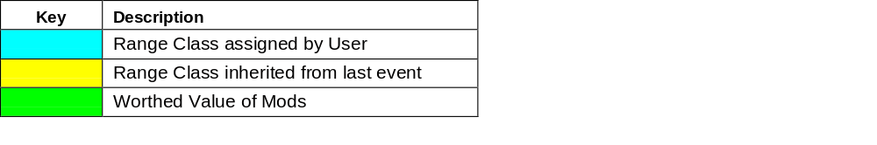

The Supported Merchandise Plans are to be displayed, Cluster by Cluster, with plans for the same Value of Mods lined-up, directly below each other. Should the User wish to assign the same Range Class to such Plans, across Clusters, then this will make it easier to do so. In order to achieve this the Supported Merchandise Plans are sorted into:

- Worthed Value of Merchandise Plan (i.e. Value of Mods),
- Cluster,
- Equipment Type (Standard first, then by Equipment Indicator),
- Range Class

These Supported Merchandise Plans are examined and the different Values of Mods determined to assist in displaying the different Values of Mods across the screen. The Equipment Types within Cluster are displayed going down the screen within any one Cluster only one element of each column will be populated.

The Equipment Types will be shown down the screen with the Standard Equipment Type shown first and marked with a red *; the other Equipment Types are to be shown in sequence of their single character Equipment Code. The Worthing Factor is shown below each Equipment Type. If there are Clusters and/or Equipment Types below the last one shown on the screen then a red ↓ is shown at the bottom-right of the grid and scroll-bars will enable the User to access them.

Across the top line of the grid the defaulted, and any previously entered, Range Classes are shown in Yellow and Cyan (light blue), respectively.

Across the screen, within the grid, are cells for worthed value of mods of each Supported Merchandise Plan for each Equipment Type. Each populated cell has the Value of Mods shown in Green and represents a Supported Merchandise Plan for a particular Equipment Type for a Cluster (within a Cluster, there can only be one populated cell in each column). If there are populated cells to the right of the last one shown on the screen then a red → is shown at the top-right of the grid and scroll-bars will enable the User to access them.

The screen will allow the User to assign a Range Class to any blank Merchandise Plan by entering the Range Class; the colour of the cells will change from Colourless to Cyan. (currently A – Z, excluding X are used, but a list will exist in Pre-Ranging; for each one a Sequence Number must be saved for each Range Class as well). In the above example the blank ones could be assigned giving:

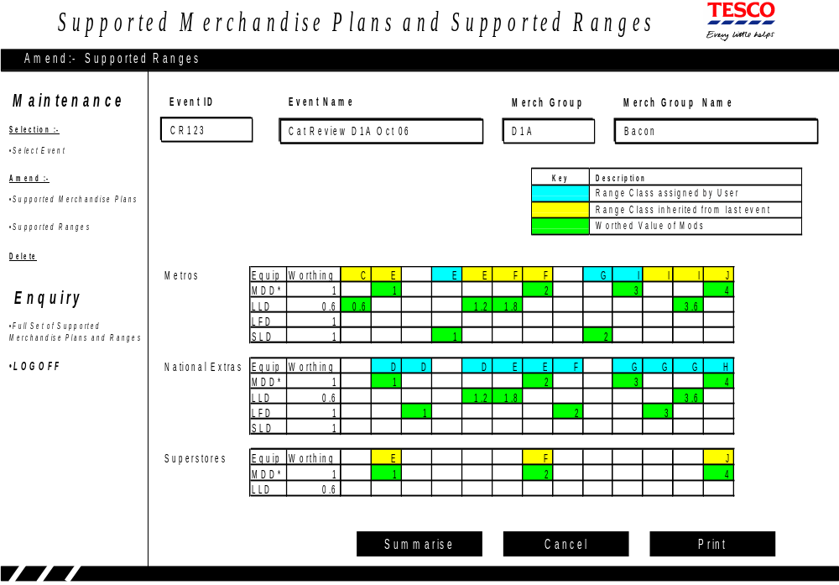

For Metros: E, G and I have been inserted.

For National Extras: every Range Class has been either entered or changed and hence are all shown as Cyan. Note that in this example the D plan is a one-mod Plan whereas for Metros the one-mod plan was designated E.

For Superstores: there are three Merchandise Plans and their Range Classes have been inherited from the previous Event.

Although there is no requirement to assign Labels for Range Classes uniformly across the Clusters they are displayed in such a way as to facilitate such labelling if required.

There remains the problem of the two Supported Merchandise Plans for Metros, MDD Equipment Type, which have the same Space but different Range Classes. These Supported Merchandise Plans are both worthed values of 2 but one inherited the Label F from the previous Event and the other has been assigned G.

The User may change the defaulted Range Class for a Merchandise Plan (again changing the colour, this time from Yellow to Cyan).

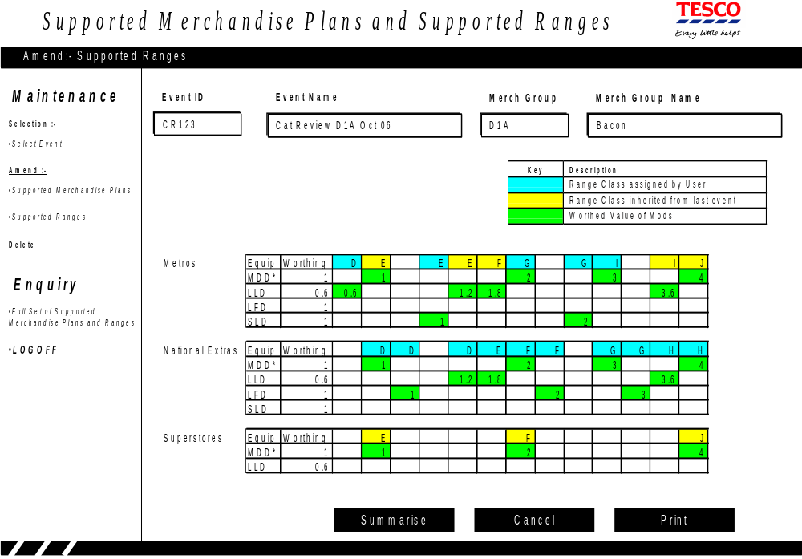

In the example above the Metro MDD F Range (Value of Mods is 2) has been amended from F to G. In addition the Metro MDD C Range has been relabelled to D. Finally the National Extra LLD G Range (Value of Mods is 3.6) Range has been relabelled to H.

When finished the User may click the Summarise button, which brings up the second screen, Summarise and View.

Clicking the Cancel button will reject all the entered assignments and return the Matrix to its last saved state. The User should confirm this action before it is effected.

Clicking the Print button prints the screen; it is important that all of the populated cells (all Range Classes across, all the Clusters and Equipment Types down) are printed not just those shown in the current window on the screen.

Field Descriptions
The only fields entered in this screen are the Range Classes, in the top row of the grid. The cells turn from Yellow (defaulted from previous Event) or Colourless (this Merchandise Plan was not supported in the previous Event) to Cyan when they are manually entered. All the other fields have been described in the function description.

Summarise and View – Introduction
The Summarise and View screen performs a number of functions; it:

- Performs certain validations and if errors exist then these are reported on and control returns to the previous screen for correction,
- It displays the achieved Worthing Factor for every Supported Merchandise Plan,
- It displays all the work done in a form which is more compact than the previous screen, which makes checking easier,
- It allows confirmation that the work has been done correctly

Summarise and View – Navigation

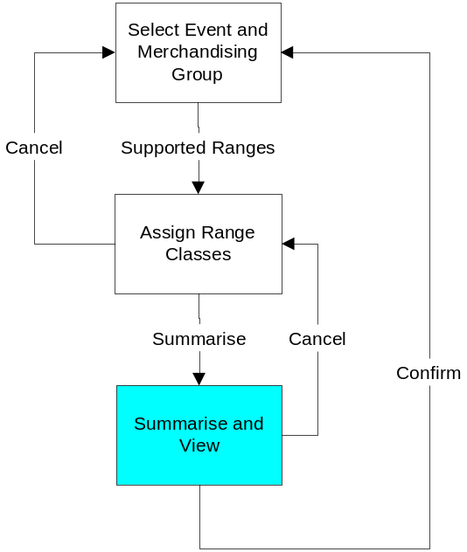

This screen is only navigated to from the first screen of this section, Assign Range Classes, using the Summarise button on that screen.

The User may Confirm all the assignments of Range Class, which saves the data and then navigates back to Event Selection.

The User may return to the previous screen, Assign Range Class, by clicking Cancel button.

Screen Layout
The following shows the Summarise and View screen, Cluster by Cluster:

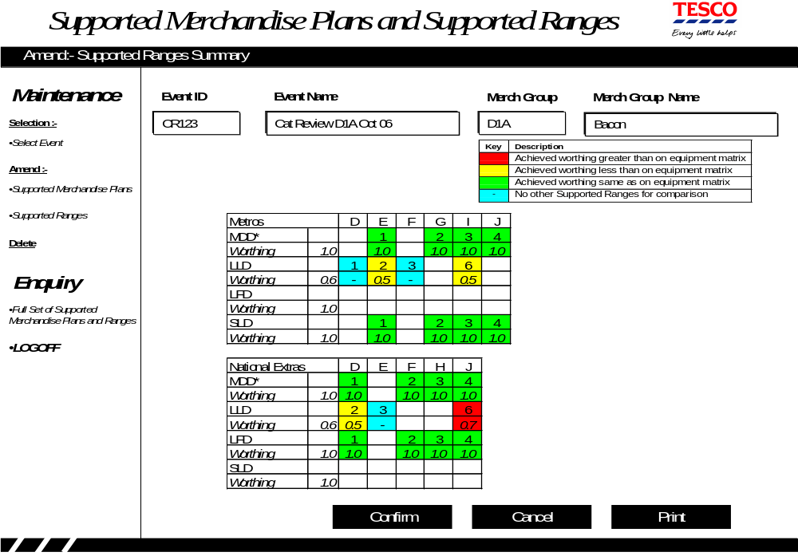

Description of Screen Function
Certain consistency checks are made before displaying the screen.

Firstly, all the Supported Merchandise Plans (for all the Equipment Types, for all the Clusters associated with this MGP) are again found. Every one of these must now have had a Range Class assigned to it. If not then an appropriate error message must be displayed and process continues from the previous screen, Assign Range Classes.

To assist in validating the assignments, the Supported Merchandise Plans are now sorted into different sequences and checks are made that, within each Cluster, within each Equipment Type:

- the Range Class Labels are in increasing sequence as the Number of Mods increases (this uses the Sequence Number saved when the list of valid Range Classes was read),
- no two Supported Merchandise Plans have the same Range Class Label
The Supported Merchandise Plans are sorted into:

- Cluster,
- Equipment Type (Standard first, then by Equipment Indicator),
- Number of Mods,
- Range Class Sequence Number,
- Range Class

The Supported Merchandise Plans are read and if within Cluster and Equipment Type the Range Class Sequence Numbers go down as the Number of Mods goes up then an appropriate error message must be displayed and process continues from the previous screen, Assign Range Classes.

The Supported Merchandise Plans are sorted into:

- Cluster,
- Equipment Type (Standard first, then by Equipment Indicator),
- Range Class Sequence Number,
- Number of Mods,
- Range Class

The Supported Merchandise Plans are read and if within Cluster and Equipment Type consecutive Plans have the same Range Class then an appropriate error message must be displayed and process continues from the previous screen, Assign Range Classes.
The screen may now be displayed. The Event Id, Event Name, MGP and Merchandising group Name are shown along the top of the screen.

The key which indicates what has been done and what achieved is shown next on the screen:

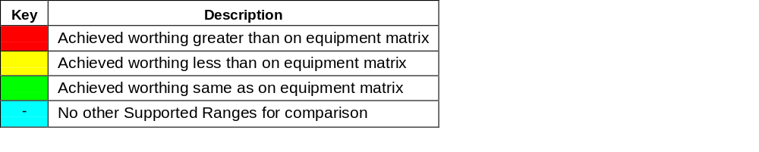

The screen shows the User a summary of the Supported Merchandise Plans defined and the Range Classes assigned to them.

Within Cluster, the sorted Supported Merchandise Plans are displayed according to their Equipment Types going down the screen and their Range Classes going across, They are colour coded, as described in the key above, according to the Worthing Factor achieved.

The achieved Worthing Factor is calculated with respect to the Number of Mods of the Standard Equipment (for this MGP) assigned to the same Range Class. In this MGP the Standard Equipment Type is ‘MDD’.

If we consider Metros, 2 Mods of LLD are in the same Range Class as 1 Mod of MDD (as in Range Class E), so the achieved Worthing Factor is 1/2 or 0.5; this is less than 0.6 and RAGed yellow. In Range Class I, 6 mods of LLD are equivalent to 3 of MDD, so the achieved Worthing Factor is again 0.5. Where the Standard Equipment is not Supported for the Range Class, in Range Classes D and F, then the achieved Worthing Factor is displayed as ‘-‘.

If we consider National Extras however, in Range Class J, 6 mods of LLD are equivalent to 4 mods of MDD, so the achieved Worthing Factor is 4/6 which is 0.666. This is greater than 0.6 and so the cell is RAGed red. Note that although this is shown rounded to 0.7, the actual value 0.666 is used in the comparison.

Clicking Confirm saves the assigned Range Classes.

Clicking the Cancel button returns the User to the previous screen, Assign Range Classes.

Clicking the Print button prints the screen; it is important that all of the populated cells (all Range Classes across and all Clusters and Equipment Types down) are printed not just those shown in the current window on the screen.

Field Descriptions
No fields are entered in this screen.

The fields displayed are described in the function description above.

Report Full Set of Supported Merchandise Plans and Ranges

Report Full Set of Supported Merchandise Plans and Ranges - Introduction

There is only one screen in this section.

The screen enables the User to print the achieved Worthing Factor for all Supported Merchandise Plans, for all Clusters, for the selected MGP and Event.

Screen Navigation

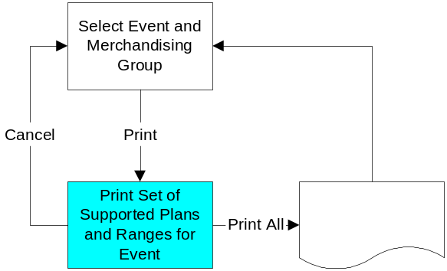

This screen is usually navigated to from Event Selection, using the left-hand pane options; navigation leads to the first and only screen.

The screen may be navigated to from any other section of the application, after the work in that section has been confirmed or cancelled.

The User may print the Full Set of Supported Merchandise Plans and Ranges for the Event and MGP by clicking the Print button or return immediately to the Event Selection screen by clicking Cancel button.

Screen Layout
The following shows the only screen:

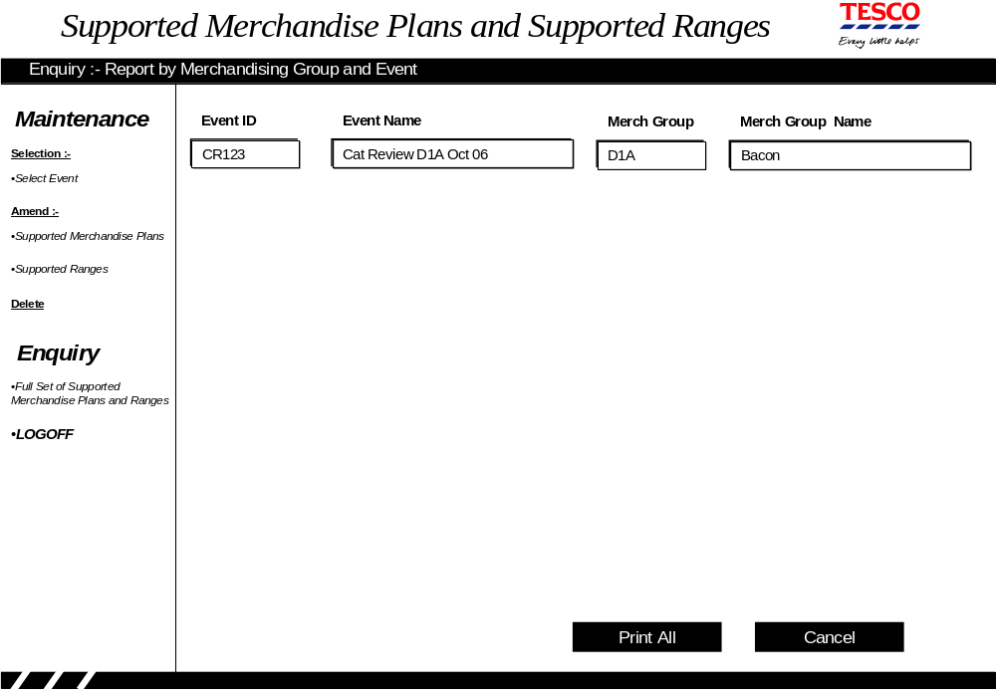

Description of Screen Function
The screen allows the User to Print the Full Set of Supported Merchandise Plans and Ranges for all the Clusters.

The Event Id, Event Name, MGP and Merchandising group Name are shown along the top of the screen.

The screen itself is blank.

If the User clicks the Print All button then a report will be produced showing summary Matrices for every Cluster associated with the MGP. The data will be similar to those shown in the Summarise and View section except there the screen is summarised for all Clusters and in the report they are shown Cluster by Cluster. These Cluster Summaries will appear in the same sequence that Clusters appeared on the Cluster Selection screen. The layout may be seen in the reporting section, 6.3.9.

Field Descriptions
There are no fields to be entered in this screen. The screen displays, and the report prints, the exactly the same details as appeared on the screens.

Delete some or all Supported Merchandise Plan and Ranges for an Event

This section enables the User to delete the matrices for some or all of the clusters in a MGP, for the Event. The screen is accessed from the left-hand navigation pane, after an Event and MGP have been selected.

There is only one screen in this section. It lists the clusters in this MGP, for which matrices could be deleted. It allows the User to select the matrices to be deleted.

The only pre-condition for navigating to this screen is that an Event and MGP must have been selected.

Deleting Supported Merchandise Plan and Ranges for an Event – Introduction
All the clusters that are defined for the selected merchandising group in Pre-Ranging, at the date of the Event, are listed on the screen.

Deleting Supported Merchandise Plan and Ranges for an Event – Navigation

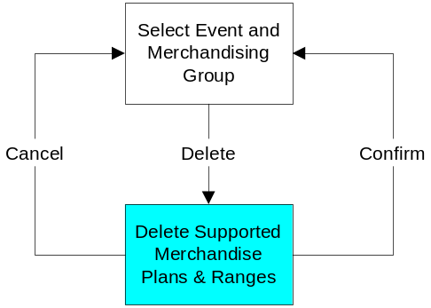

This screen can only be navigated to from Event Selection, using the left-hand pane options. This is providing the pre-conditions have been met (i.e. Event and MGP have been selected).

After working on this screen, the User may click the Confirm button, which will delete the matrices and return the user to the Event Selection screen. Otherwise the user may return to the Event Selection screen without deleting any matrices by clicking the Cancel button.

Screen layout
The following screen is used to delete matrices for a MGP for an event:

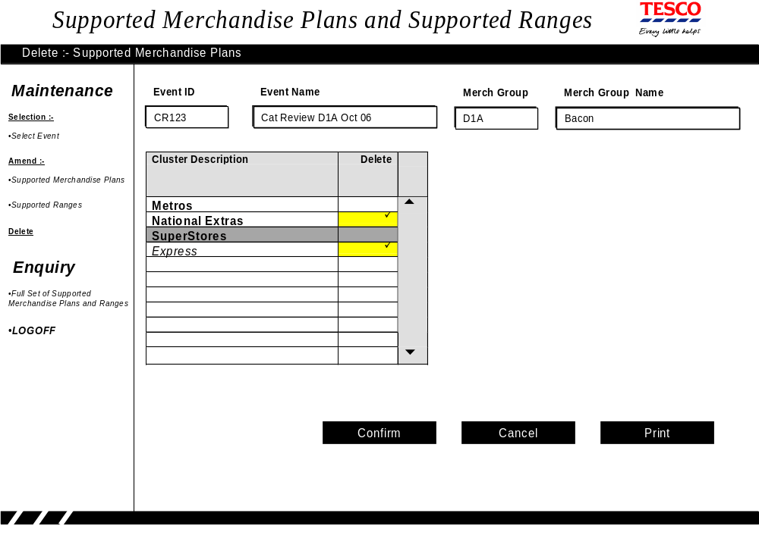

Description of screen function
All clusters for the merchandising group, that are live in Pre-Ranging at the time of the Event selected, are found. Each cluster is listed on the screen.

The clusters are sorted into:

- Clusters that are on the schedule for the Event selected
- Clusters that are not on the schedule for the Event selected

The first group of clusters is displayed in bold, and the second in Italics. Only clusters in the first group may have their matrices deleted.

The screen allows the user to select any number of clusters by clicking. The colour of the cells will then change to yellow and the cluster will be marked with a tick.

The user may deselect a cluster by clicking again. The colour of the cell will return to white and the cluster will no longer be marked with a tick.

The user must click the Confirm button to delete the matrices. The user will be prompted, and if confirmed again, the matrices for the clusters marked, for the Event and MGP selected will be deleted from the system. The user is returned to the Event Selection screen, where no Event or MGP is selected.

If the user clicks on Cancel at any time, no matrices are deleted, and the user is returned to the Event Selection screen, where no Event or MGP is selected.

Field descriptions

No fields are entered in this screen.

The fields displayed are described in the function description above.

Reports
There are two Exception Reports which may be produced for the Supported Merchandise Plans and Ranges for an Event and an MGP. These reports are used to help manage the exceptions, especially those where a Store/MGP has Space in excess of the largest (or possibly less than the smallest) Supported Merchandise Plan, for its Cluster.

Also the Enquiry Option of the application will allow the printing of a full set of Supported Merchandise Plans and Ranges. These will be useful in sign off.

Exception Report 1 - Introduction
This report shows every Store that has planned or actual Space (for the selected MGP) which is outside the ‘Range of Supported Merchandise Plans’. That is the Store/MGP has a number of mods which is either less than the lowest Supported Merchandise Plan for the Cluster (which the Store is in for the MGP), or the number of mods is greater than the largest Supported Merchandise Plan for the Cluster (which the Store is in for the MGP).

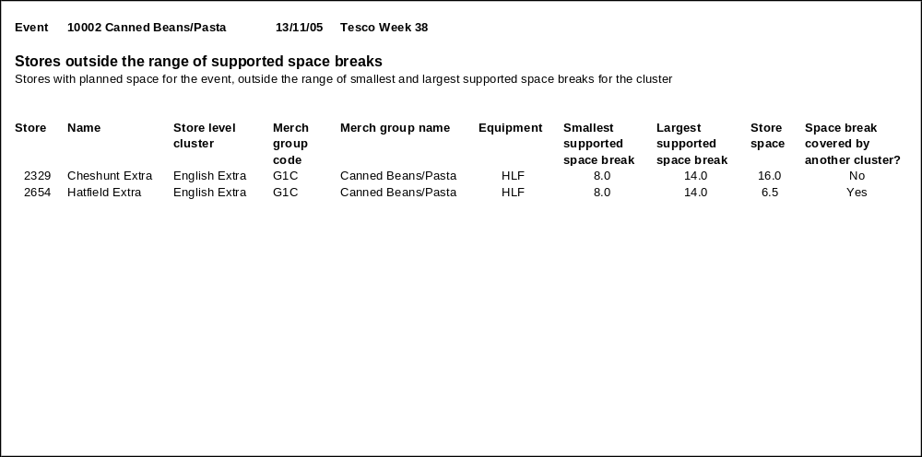
Exception Report 1 - Report Layout

Exception Report 1 - Description of the Report
This exception report shows stores where the planned space in rounded mods for a merchandising group, for a particular event, is outside the range of Supported Merchandise Plans for that store’s merchandising group ranging cluster. Stores outside the minimum and maximum may receive a poor quality link to Supported Range at the next stage of the process, so the Operations and Space teams must manage these exceptions before range class is calculated.

Having reviewed the report, it is possible in Pre-Ranging to create a ‘MGP exception’ at store/MGP Cluster level, which moves the Store/MGP to a Cluster wherein this Space is supported (e.g. moving to a different format). This report will probably be used twice for each MGP in the Event, at 18 weeks before the Event and again at 6 weeks before, when planned space is re-loaded. This report relates to requirement “Exception reporting to manage stores which are unsupported given the matrices that have been confirmed”.

Exception Report 1 - Field Descriptions

The report is in Store Number within Cluster within MGP sequence.

Field | Description | Comments
Store | Store Number, id for the Store
Store Name | Name of the Store
Store level cluster | The Cluster, among those declared for this Event, which contains the Store | The Clusters declared for a MGP for an Event must contain all Stores which will have that MGP.
Merch group code | Identifier for the MGP
Merch group name | Name of the MGP
Equipment | The Equipment Type on which Products of this Merchandising group will be merchandised in the Store | If the Equipment Type is ‘???’ or ‘MIX’ then it will be unsupported and always on this report.
Smallest supported Merchandise Plan | The smallest Merchandise Plan (for this MGP, Cluster, Equipment Type) declared on the Matrix
Largest supported Merchandise Plan | The largest Merchandise Plan (for this MGP, Cluster, Equipment Type) declared on the Matrix
Store space | Number of Mods Planned for this Store/MGP for this Event
Merchandise Plan covered by another cluster? | Whether the Matrix contains details for other clusters (whether suitable for ranging purposes or not), and the store’s Merchandise Plan is covered by this cluster

Exception report 2 - Introduction
This report shows stores which are set up as an exception at ranging cluster level for the merchandising group, but which, due to the changes to the Matrix would now be supported if they returned to their default Cluster.

Exception report 2 - Report Layout

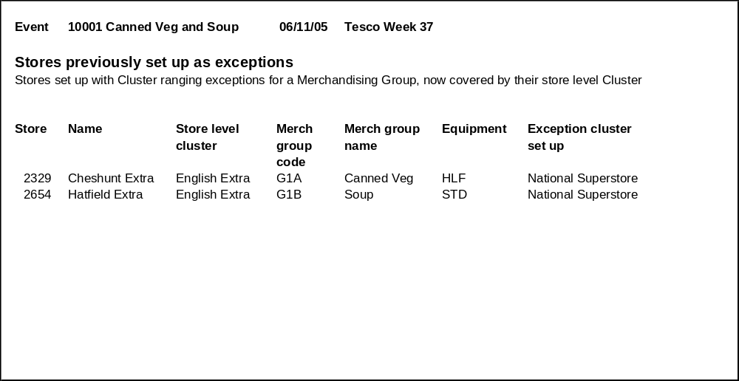

Description of the Report
This exception report shows Store/MGPs for which Cluster Exceptions are set up for this MGP and Event; that is, at MGP level, different Ranging Attributes have been set. It may be that these exceptions were made in order to obtain a better match to Plans; further it may be that recent changes in Supported Merchandise Plans and Ranges provide better cover and this exception is no longer required.

Of course if the Store/MGPs were made exceptions for reasons other than obtaining a better fit to a Plan (e.g. Newcastle’s beer) then they may well remain exceptional.

This report will probably be run a number of times when planning for an Event. There may be benefit in running the report on an on-going basis.

This report relates to requirement “Exception reporting to manage stores which are unsupported given the matrices that have been confirmed”.

Field Descriptions

Field | Description | Comments
Store | Store Number, id for the Store
Store Name | Name of the Store
Store level cluster | The Cluster, among those declared for this Event, which contains the Store
Merch group code | Identifier for the MGP
Merch group name | Name of the MGP
Equipment | The Equipment Type on which Products of this Merchandising group will be merchandised in the Store
Exception cluster set up | Which Cluster the Store/MGP is in

Full Set of Supported Merchandise Plans and Ranges - Introduction
For the selected Event and MGP, for every Cluster, the report lists every Supported Merchandise Plan and it Range Class in a similar manner to the Summarise and View Screen.

Full Set of Supported Merchandise Plans and Ranges - Layout

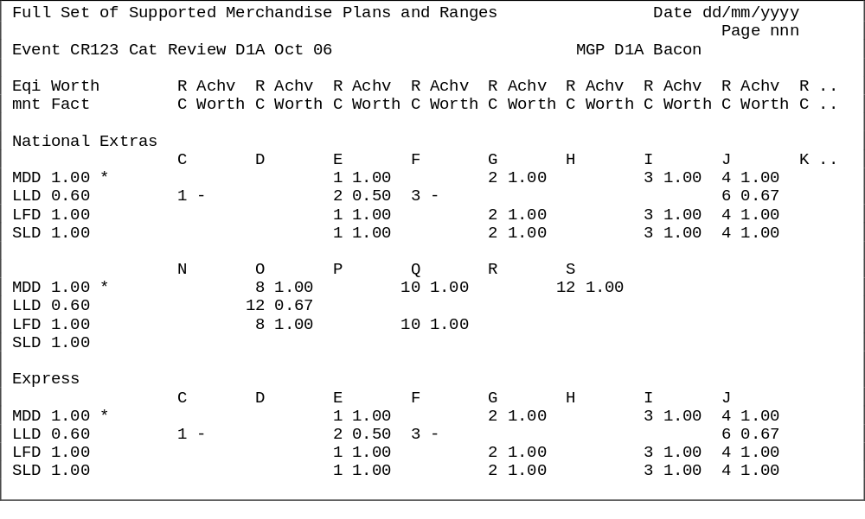

Report Description of Report
The report examines all the Supported Merchandise Plans, for the selected Event and MGP, and for all every Clusters. The Clusters will appear in the same sequence that Clusters appeared on the Cluster Selection screen.

Within Cluster the report lists every Supported Range and its Range Class in a similar manner to the Summarise and View Screen, except that instead of being consolidated then the Plans defined for each Equipment Type are shown.

For every such Supported Plan the report shows the Number of Mods and the Achieved worthing.

Field Description
The headings show the title of the report and the date and page number The second row of headings shows the Event Id and name and Merchandising Group code and description. The third section of headings shows the headings for the Equipment Type, Worthing Factor and headings for each Range Class, either from A to M or from N to Z. (In the layout above, the headings are truncated at K because of the narrowness of this page. In fact the headings will run to Range Class M).

On change of Cluster the Cluster name will be shown.

For each Equipment Type the Supported Merchandise Plans are shown as their Number of Mods and the Worthing achieved. The Worthing Achieved is calculated by finding the Supported Plan for the Standard Equipment Type for the merchandising Group for this Range Class and dividing its Number of Mods by the Number of Mods for this Equipment Type. For example, using the layout above, The National Extra Cluster has a Supported Plan for 6 mods of LLD in J Class. The J class Supported Plan on MDD (the Standard for this MGP) is for 4 mods. So the Achieved Worthing for the LLD Equipment is 4/6 or 0.6667. Note that the Standard Equipment Type is shown first followed by the other Equipment Types in sequence of their 1-digit codes. If there is no Supported Plan for the Standard Equipment for this Supported Range then the Achieved Worthing is set to “-“.

If there are Supported Plans for Supported Ranges greater than L-Range then these are save to be printed in the second half.

Other Processes

This section describes processes outside this project which may be affected by the introduction of this project.

Input Required from Other Processes
This section describes data that this project needs which must be provided by other systems.

Space and Merchandising System (GR)
Planned Space and equipment, for Store/MGPs, will be held on GR and this data will be needed by this project. GR must be amended to provide this data.

Current Actual Space and equipment, for Store/MGPs, will be held on GR and this data will be needed by this project. GR must be amended to provide this data.

A number of details, held on the Equipment Matrix, are required for this project. The Equipment Matrix is in GR, which must be used to provide this data. The data required are Equipment Types that are valid for the MGP and, for each one:

- three character Equipment Type,
- one character Equipment Indicator,
- description,
- range-to-space indicator, whether Fixed or Matching, for this MGP,
- standard equipment indicator,
- merchandising worthing factor,
- Rounding rules for this MGP.

Merchandising group Maintenance System (MGM)
Merchandising Group descriptions and relations to Supplementary Groups will be needed by this project. The MGM system, being part of the Flight-deck, will provide them in the standard way.

Pre-Ranging System
Cluster (or Store Range Group) identifiers, names, one character identifiers (formerly known as Region Code) and Stores which are in the Cluster (as well as exceptions at MGP level) will be needed by this project. The Pre-Ranging system, being part of the Flight-deck, will provide them in the standard way.

Store identifiers, descriptions, format types and country codes will be needed by this project, as well as which Merchandising groups are authorised for each Store. The Pre-Ranging system will provide them in the standard way.

Outputs to Other Processes
This section describes data that this project produces which will be provided as input to other systems.

Space and Merchandising System (GR)
The approved Supported Merchandise Plans and Ranges will need to be available to GR. There is a requirement that Stores will be able to view all Supported Merchandise Plans, which apply to the Store/MGP, which are within an x-week window from today. The value of x is a business rule; currently it is set to 6 weeks. The GR programs will need to be amended to get the data from this project and cater for multiple futures.

GR currently calculates Range Class from Space using the Supported Merchandise Plans and Ranges built from Pro-Space data. The Range Class determination must now be made using the new Supported Merchandise Plans and Ranges.

Data Warehouse System
The Data Warehouse system will need to receive the new Supported Merchandise Plan And Ranges, but only on the Launch Date of the Clusters, for the MGP, for the Event. This will involve changes to the Data Warehouse system.

Ranges in Progress & Assort
Ranges in Progress and Assort will need to receive the new Supported Merchandise Plans And Ranges and the associated live dates, as soon as the matrix is confirmed in the system, to enable Assort for ranging work and Ranges in Progress for reconciliation of Supported Merchandise Plans and Ranges.

SYSTEM REQUIREMENTS
A separate document, which applies to all applications which are part of the flight-deck, details System and Non-Functional Requirements.

These requirements are detailed under the headings:

- Environments
- Data Model
- System Interfaces
- System Maintenance
- Archiving
- Storage Requirements
- Audit Trails
- Security & Controls
- Overnight Processing & Job Schedule
- Back Ups & Restores
- Disaster Recovery & Business Continuity Plan
- Service Level Agreement (SLA)
- Operational Service Agreement (OLA)

STANDARDS

Screen & Report Design
For the standards to be adopted for screen and report design see the design documents provided separately.

Error Handling

Error Codes

Common system message
Msg. No. | Message | Trigger
1 | Data entered must be alphabetic | Numerics detected in alpha field
2 | Data entered must be numeric | Alpha characters detected in numeric field
3 | Please enter data into highlighted fields | Incomplete data
4 | Invalid date format | Date validation failed
5 | Invalid date. Date must be greater than today | Failed date validation – date too old
6 | Invalid date. Too far in the future | Date validation failed – date too far in future
7 | Code already exists | Dept code validation failed
8 | Description already exists | Description validation failed
9 | Description is too long | User attempts to enter data after the end of the field is reached
10 | The description entered is the same as an existing one. Do you wish to proceed? | Duplicate description found
11 | Choosing another task at this point will lose all changes made. Do you wish to proceed? | Another option selected from the menu bar prior to pressing the “proceed” button
12 | Cancelling at this point will lose all changes made. Do you wish to proceed? | Cancel button selected
13 | If you logoff at this point will lose all changes made. Do you wish to proceed? | The logoff button is selected prior to pressing the “proceed” button
14 | Are you sure? | To confirm that selected action is correct
15 | No details found | No details found that match the search criteria
16 | Invalid Tesco year/week number | The Tesco week number is not valid
30 | Transaction successful | All data successfully validated and processed

Supported Merchandise Plans And Ranges Specific Messages
Msg. No. | Message | Trigger
131 | There are no Equipment Types for this MGP. They must be defined before Supported Merchandise Plans. | Equipment Matrix has no Equipment Types defined for this MGP
132 | More than one Standard Equipment Type exists for this MGP. This must be corrected before Supported Merchandise Plans are defined. | More than one Equipment Type is flagged as the Standard in the Matrix for this MGP
133 | No Standard Equipment Type exists for this MGP. One must be defined before Supported Merchandise Plans. | No Equipment Type is flagged as the Standard in the Matrix for this MGP
134 | Every Merchandise Plan must have a Range Class assigned. You must go back and assign them. | There is at least one defined Merchandise Plan without a Range Class assigned to it
135 | Range Class Labels have been assigned in the wrong sequence | As the Value of Mods goes up the Range Class Sequence Number goes down
136 | Cluster ccccc, Equipment Type eee for nnn1 Mods is assigned Range Class r and nnn2 Mods has been assigned the same Range Class. | User has assigned the same Range Class to two different numbers of mods for the same Equipment Type for same Cluster
137 | Cluster ccccc, Equipment Type eee, for nnn Mods is assigned Range Class r1 yet Cluster ccccc for same number of Mods and Equipment Type is assigned Range Class r2 | User has assigned different Range Classes to two different Clusters with the same numbers of mods of the same Equipment Type
138
139
140
141
142
143
144
145
146
147
148
149
150

Message Handling
All of the application error messages produce one of the following three Alert Boxes

Message Type | Options | Actions
Error | OK | Acknowledge error and correct before proceeding
Warning | Do you want to continue  Yes  No | System completes the requested action  System returns to the input screen to allow further change without completing the action
Information | OK | Acknowledge warning and act on it later

Login & Security
For the standards pertaining to the login procedure and security see the documents provided separately.
Appendix A
Abbreviations

Abbrv. | Meaning | Description
BSD | Business System Design document | Document describing the business information and processes in the old and required for the new system
GR | Space and Merchandising System | The Space and Merchandising System which records Space in Stores and, currently, calculates Range Class from that Space.
GT&A | Global Technical & Architecture team | Advise on technical architecture and tools
MGP | Merchandising Group | A grouping of Retail Products for merchandising purposes, including selling next to each other on the same equipment in the store
NWT | Natural Work Team | Group drawn from different departments, all of whom have an interest in the Event. In this case it will usually be drawn from Merchandising, Commercial and the Space Team
ODS | Operational Data Store | Common data store across all systems
RAG | Red, Amber,  Green | An indication of performance, sometimes called ‘traffic-lighting’, where Green is Good and Red is Bad
RSM | Range, Space and Merchandising | Alias for SRM
SRM | Space, Range and Merchandising | Department responsible Space, Range Class and Merchandising of the Stores
UKBE | United Kingdom Business Expansion | Department that manages new Stores, Store Extensions and Re-Fits

Appendix B
Definition of Terms

Term | Description
Achieved Worthing Factor | The measure of the Equipment Type as implied by the Supported Merchandise Plan. So if 12 mods of this Equipment Type have the same Range Class as 4 mods of the Standard Equipment Type then the Achieved Worthing Factor is 4 / 12 or 0.33
Cat Review | Now known as New Merchandise Plan: A review may change MGPs and the Space allocated to MGPs, within Stores.
Cluster | A group of Stores, grouped for ranging purposes. Also known as a Store Range Group
Equipment Type | One of a number of different types of equipment which may be used in store to hold a particular MGP’s products
Flight-deck | The application which encompasses all maintenance of the Space, Range and Merchandising Infrastructure
Merchandising Group | A three character code used to group products together so that they are sold from the same area in the store.
Merchandise Plan | A paper report that shows where each product should be placed on the shelf taking into account range and sales rate.
Mod | The unit of shelving used in store to hold products
Planned Space Change | Centrally Planned change of a Store’s Space, to take place some time in the future. Usually this change is associated with an Event on the Merchandising Schedule
Range Class | Each store merchandising group is assigned a range class based on the space available for the merchandising group and this is used to determine what products should be stocked.
Supported Merchandise Plan | A number of mods deemed to be suitable for supporting a particular Range, for an MPG, and achieving level run down
Space, Range and Merchandising schedule | A diary of Merchandising Events and their associated attributes (Event Types, MGPs, Clusters)
Space Team | Department responsible for current and future space in Stores
Store Range Group | Alias for Cluster
Value of Mods | Amount of space, measured in mods of the Standard Equipment Type for the MGP. I.e. if a Store/MGP has space with a Value of Mods of 2 then this space is equivalent, for Merchandising purposes, to 2 mods of the Standard Equipment for the MGP.
Worthing Factor | Measure of an Equipment Type, with respect to its ability to hold a Range, compared to the Standard Equipment Type for the MGP. For example if an Equipment Type has a Worthing Factor of 0.25 then 4 mods of it are required to hold the same Range as 1 mod of the Standard Equipment Type for the MGP
Appendix C
Screen Layouts

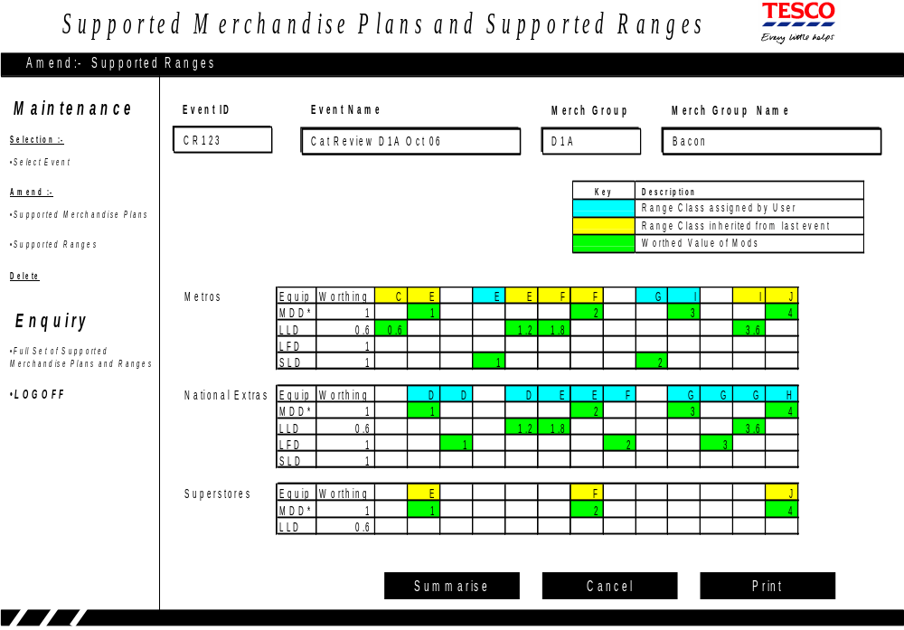
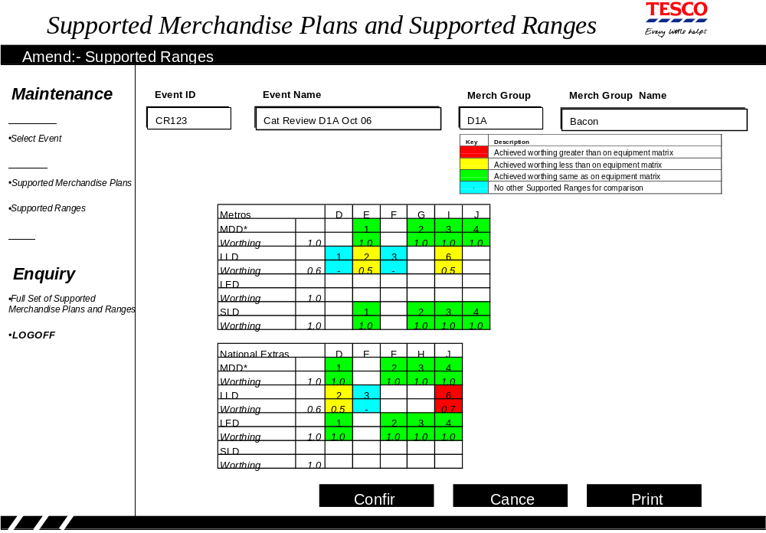
Appendix D
Infrastructure Process

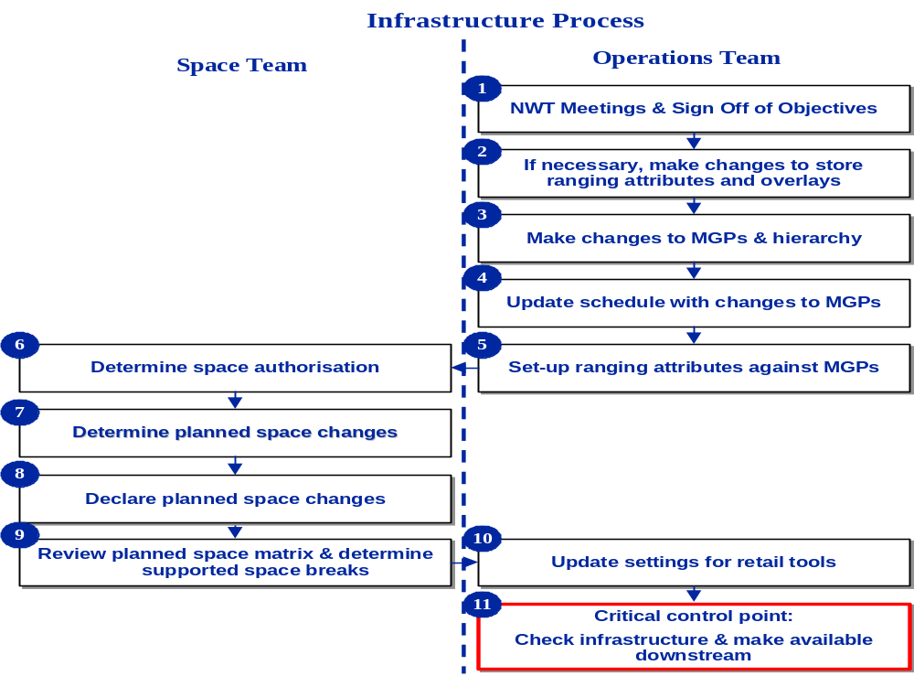
Appendix E
Business Rule for Number of Stores to be Supported

Whilst the User is striving to achieve the best possible cover in defining the Merchandise Plans it will not be possible to support every space break in every store. A Business Rule will define the minimum number of stores which must have a particular space break before it must be supported.

This ‘minimum number of stores which should be supported’ may vary depending upon Ranging Attribute Values. For example in Northern Ireland it may be that 2 stores are sufficient to justify creating a Supported Merchandise Plan whereas in England a minimum of 5 stores might be required before a separate Merchandise Plan should be built.

This ‘minimum number of stores’ will be a parameter which will be associated with every possible Ranging Attribute Value. These Parameters will be maintained by the Space Team. To determine the ‘minimum number of stores’ for a Cluster, all the Ranging Attribute Values of the Cluster are found, the parameter associated with each of these Values is found and the smallest of these parameters is deemed to be the ‘minimum number of stores’ for the Cluster.

For example suppose that the full list of Ranging Attribute Values, and their individual parameters, is defined by this table:

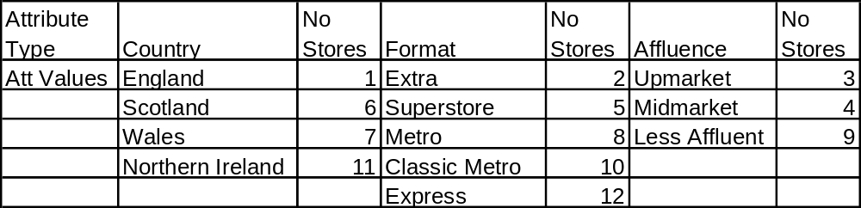
Further suppose that for the MGP and Event in question (we are always working on one MGP at a time) the following Clusters have been declared for Merchandising:

A England
B Scotland Extra
C Scotland Superstore/Metro/ClassicMetro
D Scotland Express
E Wales Upmarket
F Wales Midmarket/LessAffluent
G Northern Ireland

Then:

A England will have parameters { 1 } and the minimum is 1
B Scotland Extra will have parameters { 6, 2 } and the minimum is 2
C Scotland Superstore/Metro/ClassicMetro will have parameters { 6, 5, 8, 10 } and the minimum is 5
D Scotland Express will have parameters { 6, 12 } and the minimum is 6
E Wales Upmarket will have parameters { 7, 3 } and the minimum is 3
F Wales Midmarket/LessAffluent will have parameters { 7, 4, 9 } and the minimum is 4
G Northern Ireland will have parameters { 11 } and the minimum is 11

The exception to the above logic is that if a Cluster contains every possible Value of a particular Ranging Attribute then the Ranging Attribute is ignored when determining the parameter. For example if a particular Cluster was associated with Upmarket, Midmarket and LessAffluent values (of the Ranging Attribute ‘Affluence’) then these would all be ignored; i.e. 3, 4, 9 would not be considered when seeking the smallest ‘Number of Stores’. Similarly if a Cluster was associated with England, Scotland, Wales and Northern Ireland then these values would not be considered when seeking the smallest parameter.

